1.1 Name: Dr. Kuladip Jana
M.Sc., M.S., Ph.D., Postdoc. (U.S.A.), FRE, FSASS, FNESA
1.2 Designation and Department/Division:
Principal Scientist
Division of Molecular Medicine
Scientist In-Charge, Centre for Translational Animal Research (CTAR)
Bose Institute, P 1/12, CIT Scheme VIIM, Kolkata-700 054, India.
Phone: (+91)-33-25693322
Cell: (+91)-9007042850/9007067720
Fax: (+91)-33-23553886
E-mail: kuladip@jcbose.ac.in/
kuladip_jana@yahoo.com/
kuladip.jana@gmail.com
Website: http://www.jcbose.ac.in/bose/faculty-details/kuladip-jana
2. Date of birth: 3rd day of April, 1975.
3. Full details of Academic qualifications: (Bachelor’s degree onwards with awarding University/Institute, year, specialization, if any):
1996 B.Sc. (Hons), Physiology (major), Zoology & Botany (minor), Vidyasagar University, Midnapur, West Bengal, India, 1st class.
1998 M.Sc., Human Physiology with Community Health (specialization: Immunology & Microbiology), Vidyasagar University, Midnapur, West Bengal, India, 1st class.
2004 Ph.D., in Reproductive Medicine from Vidyasagar University, Midnapur, West Bengal.
2006 Post-doctorate in Molecular Reproductive Medicine from Garrison Institute of Aging, Texas Tech University of Health Sciences Centre, Texas, USA.
2022 Pursuing D.Sc. in Science from Vidyasagar University, Midnapur, West Bengal., India

Professional Course: M.S. in Psychotherapy & Counselling from Institute of Psychotherapy& Management Sciences, Mumbai, 2005.

4. Details and nature of present and previous employment (Positions held, employer/place of work, duration):
2005 Research Associate in a NIH (U.S.A.) project, Immunology and Vaccine Development Unit, National Institute of Cholera & Enteric Diseases (NICED), Kolkata, India,
2006 Postdoctoral Research Associate in a NIH (U.S.A.) project, Garrison Institute on Aging, Texas Tech University Health Sciences Center, Lubbock, Texas, USA.
2009 Research Associate III, Crystallography & Molecular Biology Division, Saha Institute of Nuclear Physics, Kolkata.
2010 Scientist-C, Division of Molecular Medicine, Bose Institute, Kolkata, India.
2014 Senior Scientist, Division of Molecular Medicine, Bose Institute, Kolkata, India.
2018 Principal Scientist, Division of Molecular Medicine, Bose Institute, Kolkata, India.

5. Research specialization (Major scientific fields of interest):

Molecular & Cellular Endocrinology, Reproductive Medicine, Cancer Biology, Drug development against Cancer, Diabetes, Filaria, Tuberculosis and Leismania and Use of Bio-Polymer in Tissue Engineering as well as Nano-drug development.
As we know the multidrug resistance (MDR) is a major obstacle and it severely limits the efficacy of clinical chemotherapy in the treatment of cancer. We also identified some small molecules those have an anti-proliferation and anti-metastasis potential against doxorubicin (DOX) resistant breast cancer cell lines through the induction of apoptosis/autophagy. A novel sulforaphane derivative also identified which showed very promising anti-tumor potential which intermingle with IGF1R and block the PI3K/Akt pathway along with the induction of caspase independent apoptosis. Recently we started to successful implementation of CRISPR-Cas9 or conventional genome editing of cancer cell lines to determine the key players involved in disease pathogenesis with a long-term goal of drug designing. I have a vast expertise in working with different human disease models including cancer, diabetes and infectious diseases in mice, rat & hamsters. I intend to develop and implement successful genome editing in cancer cell lines using CRISPR-Cas9 with a long-term goal of using this tool in investigating the mechanism of existing drug resistance among different cancers. I am also keen in identification and characterization of biologically relevant pathways/components involved in disease pathology in response to parasite infection and would like to contribute in the field of drug development. Efficient identification and characterization of these components should serve as the basis of identifying novel inhibitors or re-purpose existing drugs in a rational drug designing approach for treatment of multidrug drug resistant cancers and parasitic infections.

Presently, my laboratory focusing on Translational animal research in the diverse directions i.e. Molecular signalling of germ cell/ Leydig cell apoptosis by Benzo(a)pyrene and its protection by natural aryl hydrocarbon receptor (AhR) antagonist, Molecular Mechanisms of Germ-line Stem Cell Regulation: Special emphasis on Diabetes and aging, Ageing associated oxidative stress & testicular gametogenic and steroidogenic disorders: ameliorating potential of natural antioxidants,Resveratrol Induced Apoptosis in Cervical and Breast Cancer Cells: role of β- catenin and Wntsignalling, Sulforaphane inhibits Akt mediated GSK3β and FoxO3a signaling and triggers apoptosis in breast cancer. Development of nanoparticle mediated treatment strategy to target NOTCH1 in triple negative breast cancer (TNBC) Xenograft model, Novel anti-filarial and anti-cancer drug development from natural resources and to search the link between Polycystic Ovary Syndrome and both Type 1 and Type 2 Diabetes Mellitus as well as mechanism of wound healing by Calendula officinalisin diabetic condition.

6. Research interest:
(A) Molecular signaling involved in patho-physiological action of common air pollutant “Benzo(a)pyrene” in Germ cell DNA damage and apoptosis in connection to male infertility: possible protection by natural aryl hydrocarbon receptor antagonists
Benzo(a)pyrene (B(a)P) is an environmental toxicant that alters the steroidogenic profile of testis and induces testicular dysfunctions. In spite of the magnitude of the problem, the precise molecular and cellular mechanism of B(a)P mediated testicular damage and possible protective measures still remain unexplored. In the present study, we have investigated the molecular signalling of B(a)P and the ameliorative potential of the natural aryl hydrocarbon receptor (AhR) antagonist and antioxidant- 3,5,4'-trihydroxy-trans-stilbene (Resveratrol) on B(a)P induced male reproductive toxicity. Studies carried out in adult male Wistar rats significantly showed that B(a)P treatment resulted in p38 MAPK activation and increased iNOS production along with testicular apoptosis and steroidogenic dysfunction. Our study also highlighted that resveratrol co-treatment maintained testicular redox potential, increased serum testosterone level and enhanced major testicular steroidogenic proteins (CYPIIA1, StAR, 3β HSD,17β HSD) expression and subsequent onset of apoptosis. Resveratrol co-treatment also showed significant inhibition of protein and mRNA levels of testicular cytochrome P4501A1 (CYP1A1), which is the major B(a)P metabolizing agent for BPDE-DNA adduct formation. Resveratrol also significantly decreased the B(a)P-induced AhR protein levels, its nuclear translocation and subsequent promoter activation, thereby decreasing the expression of CYP1A1. Resveratrol down-regulates B(a)P-induced testicular iNOS production through suppressing the activation of p38 MAPK and ATF2 thereby improving the oxidative status of the testis and inhibiting apoptosis. Our findings thus cumulatively suggest that resveratrol exhibits both anti-initiating effects of B(a)P by modulating the transcriptional regulation of CYP1A1 and acting as an antioxidant thus preventing B(a)P-induced oxidative stress and testicular apoptosis.
(B) Insulin defective stage of type 2 Diabetes (IDS-T2DM) induced testicular Germ cell death/apoptosis in association with the up-regulation of Nrf2 expression: Ameliorative potential of sulforaphane (SFN) and resveratrol (RES)

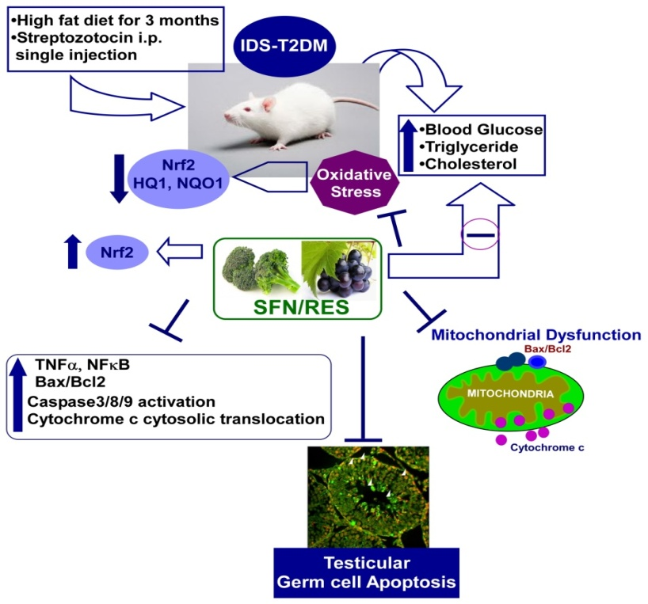
Diabetes-induced testicular celldeath is due predominantly to oxidative stress. Nuclear factor (erythroid-derived 2)-like 2 (Nrf2) is an important transcription factor incontrolling the anti-oxidative system and is inducible by sulforaphane(SFN) and resveratrol (RES). To test whether SFN/RES prevents diabetes-induced testicular germ celldeath/apoptosis, an insulin-defective stage of type 2 diabetes (IDS-T2DM) wasinduced in mice. This was accomplished by feeding them a high-fatdiet (HFD) for 3 months to induce insulin resistance and then giving oneintraperitoneal injection of streptozotocin to induce hyperglycemiawhile age-matched control mice were fed a normal diet (ND). IDS-T2DMand ND-fed control mice were then further subdivided intothose with or without 3-months SFN/RES treatment. IDS-T2DM inducedsignificant increases in testicular germ cell death/apoptosis presumably through receptorand mitochondrial pathways, shown by increased ratio ofBax/Bcl2 expression and cleavage of caspase-3 and caspase-8 withoutsignificant change of endoplasmic reticulum stress (GRP78/CHOP). Diabetes alsosignificantly increased testicular oxidative damage and inflammation (TNFα and NFκB).All of these diabetic effects were significantly prevented by SFN/REStreatment with up-regulated Nrf2 expression. These results suggest thatIDS-T2DM induces testicular germ cell death/apoptosis presumably throughcaspase-8 activation and mitochondria-mediated cell death pathwaysand also by significantly down-regulating testicular Nrf2 expressionand function. SFN/RES up-regulates testicular Nrf2 expression and its targetantioxidant expression, which was associated with significant protectionof the testis from IDS-T2DM-induced germ cell death.
(C) A microtubular dynamics interfering trans-stilbene derivative compound G drives G2/M arrest, apoptosis and impedes cancer progression.
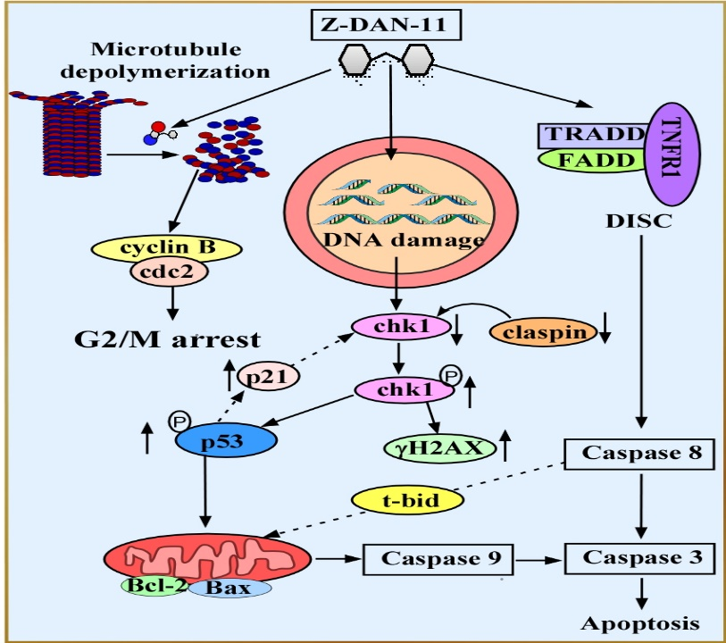Resveratrol, a trans –stilbene polyphenolic compound and its synthetic analogs have been widely used bioactive molecules due to their remarkable chemopreventive potential. Here, we have identified a novel resveratrol analog, compound G ((Z)-3-(3, 4-dimethoxyphenyl)-2-(3, 4, 5-trimethoxyphenyl) acrylonitrile (Z-DAN-11)which inhibits proliferation of several cancer cell linesin vitrothrough microtubule depolymerization that induced G2Marrest and consequently leads to apoptotic cell death. Importantly, compound G shows limited cytotoxicity to normal cells as compared to cancer cells. Moreover, insight into the molecular and mechanistic detailed studies we reasoned that compound G induces increase in the expression of pro-apoptotic proteins and decrease in the expression anti-apoptotic proteins that decisively helps the activation of caspase 8, caspase 9, caspase 3, leading to PARP-1 and cell death via intrinsic and extrinsic pathways of apoptosis. More importantly, we also have established the crucial contribution of tumor suppressor protein p53 in compound G mediated apoptosis. Interestingly, the compound G also imparts its anti tumorigenic effect by inhibiting clonogenic property and anchorage independent growth potential of cancer cells. Finally, in vivo study with immune-competent syngeneic mice tumor model shows thatadministration of compound G is able to impede tumor progression without any side effects. So, our presently studied novel trans-stilbene derivative compound G has tremendous anti-tumorigenic potential and can be added to the current regimes of chemotherapy.
ROS

(D) A novel sulforaphane derivative impedes cancer cell growth progression through G2/M arrest and ROS mediated caspase independent apoptosis.

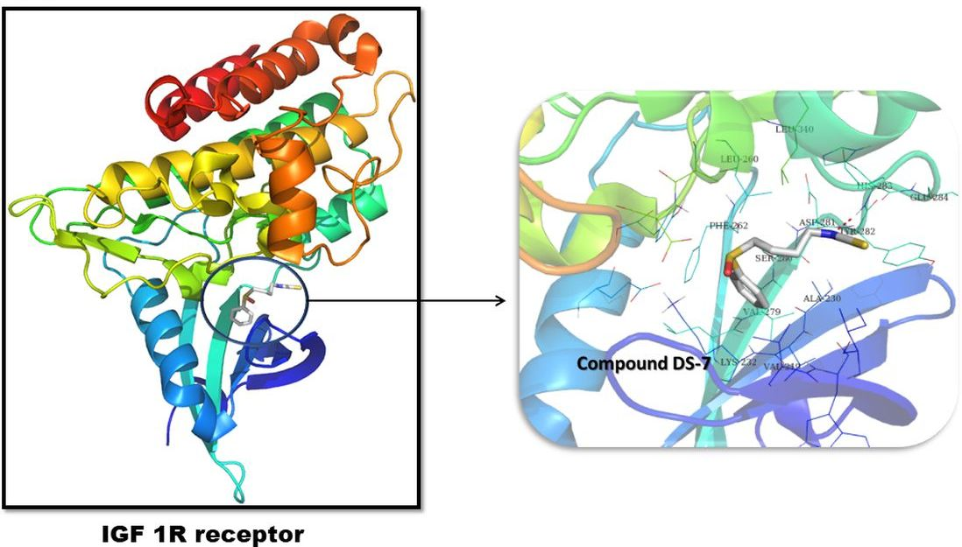
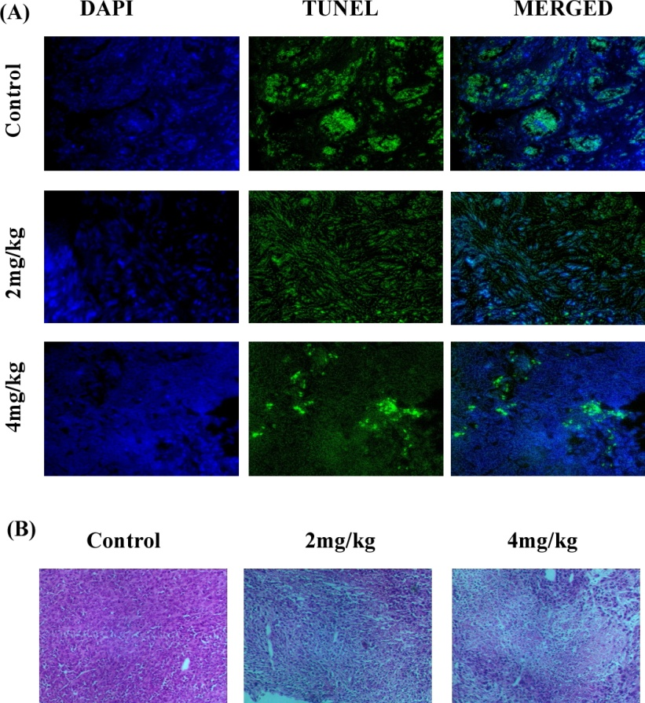
An array of suforaphane derivatives were synthesized and evaluated for their cytotoxic potentials on various murine and human malignant cell lines. One such derivative was effectively opt for out as most potent with high cytotoxic effect against cancer cells and less toxicity against normal cell lines. Our present study established ROS induced mitochondrial dysfunction and finally apoptosis induction by the lead compound. The inhibition of cell propagation was linked to the data confirming G2/M phase arrest. The mitochondrial dysfunction was confirmed by the Bax/Bcl-2 ratio. The lead compound suppressed the NRF-2 protein expression thus increasing the free radicals in the tumor cells. The derivative induced a ROS mediated caspase-independent apoptosis as the western blot data confirmed no caspase activation. The compound showed to intermingle with the IGF1R and block the PI3K/Akt pathway. The augmentation inhibitory outcome of the lead compound was confirmed by the 4T1 injected Balb/c tumor model.

(E)Evaluation of anti-filarial efficacy of the novel piperine derivative through disruption of redox homeostasis with synchronized activation of apoptosis.
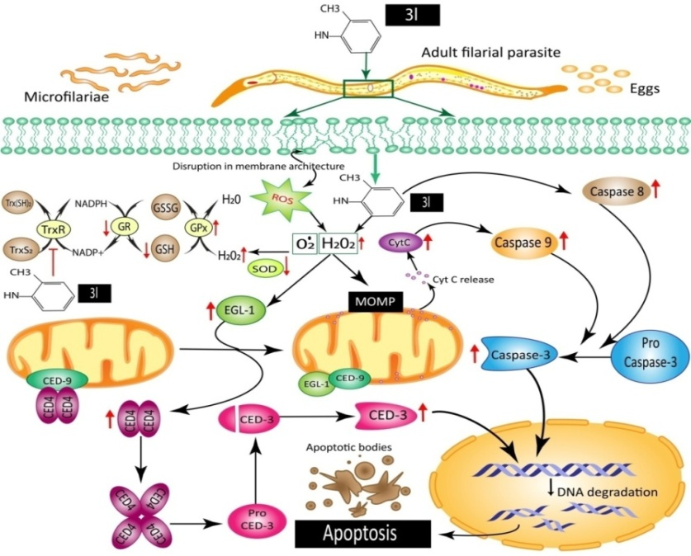
A series of novel piperine derivatives were synthesized and were evaluated for its antifilarial potential against the bovine filarial parasite Setaria cervi. One of the piperine derivative (3l)showed the highest efficacyamong the selected other compounds. The antifilarial activities its exhibited were clearly fuelled through disparity of the internal redox homeostasis as evidenced from the alterations in the enzymatic and non-enzymatic antioxidants level which ultimately shifted towards activation of pro-apoptotic signaling cascade eventually leading to the death of the parasites. The ability of the compound 3l to bind thioredoxin reductase (TrxR) and CED-3 protein are the key findings of this study. The present study supported with several biological experiments is therefore a maiden report on the antifilarial effectiveness of these novel piperine derivatives.
(F) Plastic Waste Derived Biodegradable and Biocompatible Polyester for Bone Tissue Engineering (In collaboration with Dr. K. Sarkar, Dept. of Polymer Sciences, Univ. Of Calcutta)
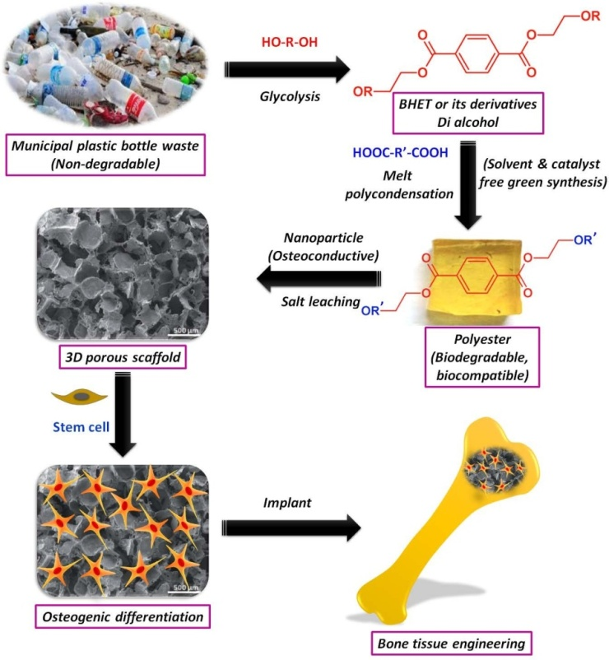
It is widely believed that engineered tissues could revolutionize medicine and offer promising
new treatments for many debilitating diseases. In tissue engineering, a scaffold should ideally be
non-toxic, biodegradable, and highly porous with interconnected architecture to support cell
attachment, proliferation and extra-cellular matrix (ECM) production to ultimately facilitate
tissue generation. In addition, it should possess optimal mechanical and physical properties. The
currently available library of such materials is limited and expensive adding to the already high
costs of these emerging therapies. There is a need for biomedical polymers derived from low
cost, renewable sources and recycled waste that could offer cost effective solutions.
The use of polyethylene terephthalate (PET) has greatly increased because of its widespread
application in packaging of food and drinks. This has resulted in an ever-growing volume of post-
consumer municipal PET waste. Therefore, recycling of waste PET has become a significant global
challenge. PET can be recycled by various techniques such as glycolysis, aminolysis and hydrolysis
to get useful monomer such as bis-hydroxyethylene terephthalate (BHET) or its derivatives which
may be used as one of the good source of monomer for the synthesis of polyester. Therefore, a
large volume of PET municipal waste may be a potential source of low cost polymers. The
hypothesis of the proposed proposal consists of the following points (Scheme 1):
- Recycling of municipal plastic PET waste by glycolysis technique to get BHET or its
derivatives.
- Synthesis of a library of biodegradable and biocompatible polyester by solvent and
catalyst free melt polycondensation technique by using recycled BHET and its derivatives.
- Fabrication of 3D porous scaffold by salt leaching technique containing inorganic
nanoparticle as osteoconductive and reinforcing material.
- In vitro biocompatibility and bone formation study by seeding human mesenchymal stem
cell (hMSC).
- In vivo implantation for bone formation.

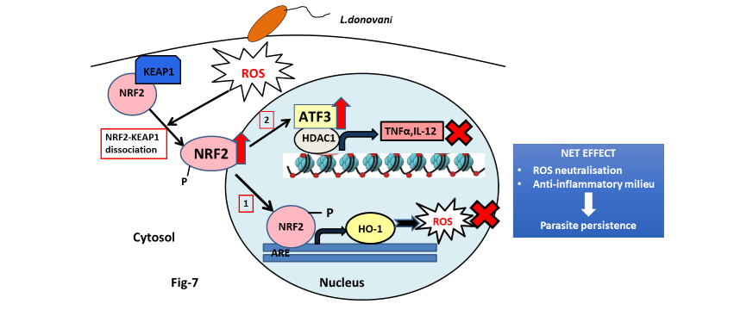(G) Leishmania donovani targets host transcription factor NRF2 to activate anti-oxidant enzyme HO-1 and transcriptional repressor ATF3 for establishing infection (In collaboration with Dr. A. Ukil, Dept. of Biochemistry, University of Calcutta)
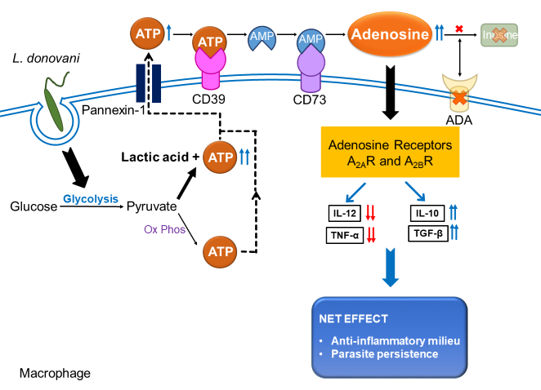
In order to gain the knowledge about exploitation of host defence by infectious organisms, we selected a model macrophage associated disease, visceral leishmaniasis. Macrophages play an important role in the first line of defense against various pathogens through generation of ROS and production of various pro-inflammatory cytokines. Thus, they serve as a very powerful guard protecting our body from pathogens. Leishmania donovani, the causative agent of fatal visceral leishmaniasis, is an obligate intracellular parasite inoculated into mammals by the bite of its vector sand fly. Once transmitted to the host, the infective promastigote forms are rapidly phagocytosed by these macrophages. Within these cells, the parasite along with combating against the anti-microbial defence arsenals of the macrophages has to survive within the harsh environment of the phagolysosomes. Thus, the parasite upon infecting a macrophage must subvert or impair the defence arsenals in order to successfully survive and propagate infection.Generation of Reactive oxygen species (ROS) is one of the primary anti-microbial activities of a macrophage, when it encounters a pathogen. ROS can even ultimately result in apoptosis of the host harboring the pathogen, and thereby results into parasite clearance. Thus, the parasite has to suppress production of reactive oxygen species. Another important defence arsenal put forward by an infected macrophage is both membrane and cytosolic receptor mediated pro-inflammatory responses. The initial innate immune response of generation of pro-inflammatory cytokines like IL-12 and TNF-α may recruit inflammatory cells and T cells necessary for resolution of infection.In order to succeed against host cell, Leishmania requires substantially high energy. Now, as the intracellular parasite andthe host cell utilise the same host energy sources, therefore knowledge of metabolic status of infected macrophage leading to energy production i.e. ATP generation, also seems extremely important to address molecular signalling of infection. Adenosine 5’-triphosphate (ATP), the universal energy currency of a cell, fuels for variousvital processes necessary for maintenance of a cell and also act as an intracellular andextracellular messenger. The main source of ATP is the catabolic part ofcarbohydrate metabolism where glycolysis is followed by TCA cycle and oxidative phosphorylation. ATP generated within a cell, apart from acting as a source of energy, may act as a signalling molecule both intra-cellularly and even extracellularly.Various stimuli like stress, hypoxia, inflammation and ROS are found to induce ATP release from cells with the help of various ATP release channels and even via vesicular exocytosis in a non-lytic mechanism.Released extracellular ATP (eATP) often act as a signalling molecule and regulate various cellular processes. Thus, extracellular ATP concentration is also very crucial. High extracellular ATP acting as a ‘danger signal’ can even promote inflammation through the P2X7-receptor dependent activation of the NLRP3 inflammasome, leading to production of pro-inflammatory cytokine IL-1β. So, ATP level in the extracellular environmentis usually maintained with the help of various ATP hydrolysing enzymes of macrophage like ecto-apyrase, pyrophosphatases, phosphodiesterases and ecto-adenosine triphosphatases (eATPase). So, Leishmania must be utilising these enzymes to maintain eATP concentration. Moreover, after evasion of first line of defence, parasite induces the host to generate immunosuppressive molecules, which favor their intracellular survival. Since apoptosis is the last resort for an infected cellto get rid of pathogens, Leishmania finally have to inhibit host cell apoptosis to ensure their persistent survival.

Translational Animal Research works:
More than 20 years of experience in animal handling, breeding, experimentation as well as more than 50 International publications related to small and large animals. Worked with StAR and COX-2 knockout mouse as well as COX-2 over expressed Transgenic mouse in Garrison Institute on Aging, Texas Tech University of Health Sciences Centre, Texas, USA. Attended, participated and organized several rat and mouse Bio-methodology workshops.
I am established myself as a highly motivated and vibrant Animal Research Scientist as well as Molecular Reproductive Biologist and Endocrinologist as well as Cancer Biologist at Div. of Mol. Medicine, Bose Institute, Kolkata. I have taken a pioneer role to establish the State of the Art and world class Centre for Translational Animal Research (CTAR), a Central Animal House and Research Facility in North Eastern Part of India and did innovative research in the areas of Modern Laboratory Animal Sciences. I have a significant and unique experience in the maintenance and management of knockout/transgenic & Xenograft mouse facility. I am well versed with the Laws or guidelines that permit and control the use of non-human animals for scientific experimentation. I worked several years in USA in close association with Jackson Laboratories. I was participated in several seminars, workshops related with the experiments onanimals and drug testing. I am the member in several National & International Committees related with animal welfare.I am well versed with the Guide for the Care and Use of Laboratory Animals in Bio-medical Research in USA, UK, and Canada etc. I have more than 20 years of experience on Standard Operating Procedures (SOP) for Institutional Animal Ethics Committee (IAEC) of the CPCSEA.
8. Development of the Animal Research Facility at Bose Institute.
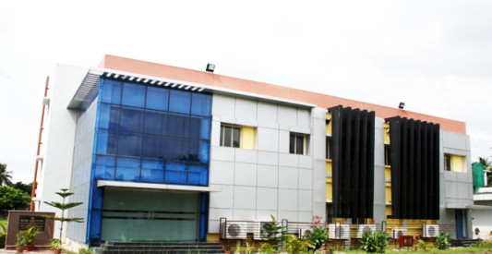
I am serving as a Scientist- In-Charge, Centre for Translational Animal Research (CTAR)as well as in "Institutional Animal Ethics Committee (IAEC)"&takes prime role to establish and maintenance of “Central Animal House & Research Facility"(CTAR) at Bose Institute. This is a state-of-the-art world class environmentally controlled "Central Animal House and Research Facility” for Developmental and Toxicology Research" with all facilities for breeding, maintenance, experimentation on small laboratory animals and it has been exclusively developed in a plinth area of 15,000 sq. ft. This Animal facility will be utilized for experimental research in accordance with the principles of good laboratory practices and CPCSEA, Ministry of Environment, Forest & Climate Change, Government of India guidelines. Further, it facilitates research and development in partnership with academic Institutions, Industries and funding agencies for drug discovery-cum-validation and devices of translational medical research with the basic objective of advancement of biological knowledge which is useful for saving the lives and /or alleviating the suffering of human being, animals and plants. However, such experiments are performed with due care so as to minimize the pain inflicted on animals. The Centre is also involved in skilled manpower development through education and training in laboratory animal care and experimental techniques. The main objective of the Centre is to supply defined strains of laboratory animals like mice, rats, guinea pigs, hamsters and rabbits for Bio-medical Research to the scientific community of the Eastern and North eastern part of India.

Future Planning:
- Maintenance of Knockout mouse, Xenograft mouse for biological research
- 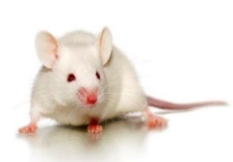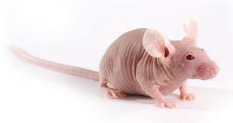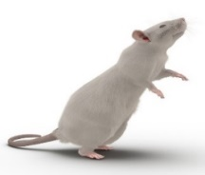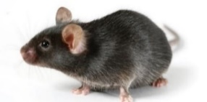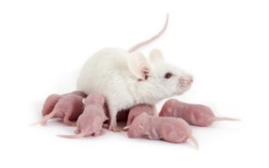Maintenance of NOG (NOD/Shi-Scid/IL-2Rγ^{null})/NSG (NOD.Cg-Prkdc^{scid} IL2rg^{tm1Wjl}/SzJ) Mouse

- Humanized mouse model will be maintained for biological & medical research for human therapeutics

The CTAR maintains animal under pathogen-free conditions

9. Collaborators:
1. Prof. Santi P. Sinhababu, Visva Bharati, Santiniketan
2. Prof. Jayati Basu & Manikuntala Kundu, Bose Institute
3. Prof. ParimalKarmakar, Jadavpur University.
4. Prof. Baidyanath Chakraborty, Institute of Reproductive Medicine
5. Prof. Gaurisankar Sa,Bose Institute
6. Prof. Tanya Das, Bose Institute
7. Prof. Chittaranjan Sinha, Jadavpur University
8. Prof. Debasish Das, University of Calcutta
9. Prof. Anup Kumar Misra, Bose Institute
10. Prof. Debapratim Das, IIT, Guwahati

10. Awards/Honor Received:
- The Biography included in Americas “Who’s Who in Medicine & Healthcare”, 2008-2009.
- DST-Fast-Track Young Scientist Scheme Award, 2010.
- Young Scientist Travel Award, 2010 from ACC&D (Portland, Oregon, U.S.A.)
- Young Investigator Award, 2011 from Parsemus Foundation (San Francisco, California, USA).
- Nominated as “International Scientist of the Year, 2011” by International Biographical Centre, Cambridge, U.K.
- Scientific Award of Excellence for 2011" by American Biographical Institute, San Francisco, California, U.S.A.
- Young Scientist Travel Award, 2012, from International Congress on Animal Reproduction (ICAR)”, Vancouver, British Columbia, Canada.
- Selected and Trained as a CPCSEA Nominee, Ministry of Environment & Forests, Govt. of India.
- Young Scientist Travel Award, 2013 from ACC&D (Portland, Oregon, U.S.A.)
10. Young Scientist Award, 2014 from Parsemus Foundation, Berkley, California, U.S.A.
11. Outstanding Scientist Award, 2015 from Venus International Foundation, India.
12. Bharat Bikas Award, 2017 for outstanding contribution in Molecular Medicines.
13. Rastriya Gaurav Award, 2018
14. Fellow of “Scholars Academic and Scientific Society” (FSASS).
15. Honorary Rosalind Member of London Journal Press
16. Honorary Member, Society for Redox Biology & Medicine, USA
17. Fellow of Reproduction & Endocrinology (FRE) from SRBCE
18. Fellow of National Environmental Science Academy (FNESA)
19. Outstanding Scientist 2022, INSO International Scientist Award on Engineering, Science & Medicines.
20. Eminent Scientist of the Year Award 2022 from National Environmental Science Academy

11. Editors/Editorial Board:

- Translational Medicine
- Journal of Translational Medicine and Epidemiology.
- Current Medicine
- Journal of Cancer Research and Molecular Medicine
- Annals of Translational Medicine & Epidemiology
- Frontiers in Endocrinology
- International Journal of Obstetrics and Gynecology
- Austin Endocrinology & Diabetes case Reports.
- American Journal of Medical & biological research
- Journal of Molecular Genetics & Medicine
- Current Clinical Pharmacology
- World Journal of Preventive Medicine
- Advances in Pharmaceutical Sciences
- Journal of Biomedical Research & Environmental Sciences
- Current Reviews in Clinical and Experimental Pharmacology
- Journal of Cancer Biology
- Current Indian Science (Section Editor, Biochemistry)
- Exploration of Biomat-X

12. Reviewer:
1. Journal of Endocrinology/Endocrinology 2. Molecular Cellular Endocrinology 3.Toxicological Sciences 4. Andrology 5. Asian Journal of Andrology 6. Food & Chemical Toxicology 7. Ecotoxicology & Environmental Safety 8. Fertility & Sterility 9. Contraception 10. Reproductive Toxicology 11. Molecular Cellular Biochemistry 12. Molecular Reproduction & Development 13. Journal of Trace Elements in Medicine & Biology 14. Molecular Human Reproduction 15. Life Sciences16.Reproduction 17. Frontiers in Nutrition 18. Frontiers in Immunology 19. Frontiers in Endocrinology and 20. Cell Death & Disease etc.
13. Membership of Scientific Bodies:
1. The Science Advisory Board, USA
2. Society for the Study of Reproduction and Fertility
3. Society for Reproductive Biology and Comparative Endocrinology.
4. The Physiological Society of India.
5. Indian Society for Translational Research
6. DNA Society of India
7. Scholars Academic and Scientific Society
8. National Environmental Science Academy
9. National Academy of Biological Sciences
10. Honorary Rosalind Member of London Journal Press 2021
14. Ph.D. guidance:
Eight (8) are already awarded and Six students (SRFs) have already been registered under the Ph.D. Programme in the University of Calcutta/Jadavpur University where I am acting as a Supervisor/Joint-Supervisor. One DBT-RA and one CSIR-Project RA were also worked under my supervision.
15. Teaching activities:
Taught special paper classes in Biochemistry (Cell signalling, hormone action, cancer signalling and Immunology) and Reproductive Biology (Reproduction, Endocrinology, Reproductive and endocrine disorders etc.) of M.Sc. (Physiology) students of University of Calcutta and Ram Mohan College as well as Integrated M.Sc.-Ph.D. classes at Bose Institute.
16. CPCSEA, Ministry of Environment, Forest & Climate Change, Govt. Of India Nominee:
Serving as a "CPCSEA Nominee" in different Institutes like Visva Bharati, Chittaranjan National Cancer Institute, Indian Institute of Chemical Biology (IICB),Indian Association for the Cultivation of Science (IACS), Jadavpur University, Vidyasagar University, Institute of Post-Graduate Medical Education & Research (IPGMER) , Institute of Reproductive Medicine, School of Tropical Medicine, All India Institute of Hygiene & Public Health, IQ City Medical College, Krish Biotech Research Pvt. Ltd. etc.

17. Advisor (Honorary.)
Serving as an Advisor (Honorary) at WBLDCL, Govt. of West Bengal for the Establishment of a State-of-the-art Preclinical Animal Research Centre (CRO/State Centre for laboratory Animal sciences (SCLAS)) funded by Govt. of India.

18. List of Extramural Funded Projects:
1. SERC Fast Track Proposals for Young Scientist Research Scheme Entitled " Molecular Signalling Involved in patho-physiological Action of Common Air Pollutant Benzo(a)pyrene in Testicular DNA Damage and Apoptosis in Connection to Male Infertility: Possible Protection by Natural Aryl Hydrocarbon Receptor antagonists" from DST, Govt. of India. (PI: Dr. Kuladip Jana). (Completed on 31st March, 2015, 17.14 lakh)

2. “Targeted delivery of nano-conjugated Methylglyoxal to cancer cells and understanding the bioenergetics difference between normal and malignant cells at molecular level” from DST, Govt. of India. (PI: Prof. Manju Ray; Co-PI: Dr. Kuladip Jana), (Project started from 01 January, 2014 with an appointment of a JRF and a R.A., 39.85 lakh).

3. “Assessment of the anti-cancer effect of Methylglyoxal in combination with conventional anti-cancer drugs at metronomic doses with special reference to cancer stem cells” from CSIR, Govt. of India (PI: Prof. Manju Ray; Co-PI: Dr. Kuladip Jana), (Project funded on 10/05/2016, 21.78 lakh).

4. “Development of Recombinant Vaccine for Aspergillus-related Asthma and Allergic Broncho-Pulmonary Aspergillosis” from The Wellcome Trust/DBT India Alliance (PI: Dr. Gaurab Sirkar; Co-Investigator: Dr. Kuladip Jana), (Project funded on 01 April, 2019, Rs. 1, 69, 16,460/- at Visva Bharati University).
19. Attended National & International Conferences:
Attended several National and International conferences and delivered lectures and chaired sessions.

20. List of Important research publications: (Citations: 3500; H index: 30)

- Karim S, Halder S, Mukherjee S, Debnath U, Misra A, Jana K*, Das D*. Glutathione Depleting a Chemoselective Novel Pro-Oxidant Nano Metal-Organic Framework Induced G2/M Arrest and ROS Mediated Apoptotic Cell Death in Human Triple Negative Breast Cancer Cell Line. ACS Applied Materials & Interfaces 2023, 15: 26442-26456. (Impact Factor: 10.383)
- Saha R, Haldar S, Pradhan SS, Jana K, Sarkar K. Superior gene transfection efficiency in triple negative breast cancer by RAFT-mediated amino acid-based cationic diblock copolymers. Journal of Materials Chemistry. B. 2023, 11: 3617-34. (Impact Factor: 7.571)
- Pariary R, Dolui S, Shome G, Mohid SA, Saha A, Ratha BN, Harikishore A, Jana K, Mandal AK, Bhunia A, Maiti NC. Coomassie brilliant blue G-250 acts as a potential chemical chaperone to stabilize therapeutic insulin. Chemical Communications (Camb). 2023(Impact Factor: 6.065)
- Paul S, Dutta B, Halder S, Shit M, Ray P, Ray PP, Jana K, Sinha C. Double advantages of 2D Coordination Polymer of Coumarinyl-Pyridyl Schiff base decorated Zn(II) : the fabrication of Schottky device and Anti-carcinogenic activity Applied Organometallic Chemistry 2023 (In Press) (Impact Factor: 4.072)
- Lepcha TT, Kumar M, Sharma AK, Mal S, Majumder D, Jana K, Basu J, Kundu M. Uncovering the role of microRNA671-5p/CDCA7L/monoamine oxidase-A signaling in Helicobacter pylori mediated apoptosis in gastric epithelial cells, Pathogens and Disease, 2023, 81: ftad006 (Impact Factor: 3.951)
- Ghosh, S., Paul, S., Halder, S., Shit, M., Karmakar, A., Nandi, JB, Jana, K. and Sinha, C., 2023. Trace level CN− measurement by ‘turn-on’emission using Coumarinyl-Benzothiazolyl Schiff base probe in living and non-living environment. Journal of the Indian Chemical Society, 100: p.100957 (Impact Factor: 0.284)
- Samanta SK, Maiti K, Halder S, Guria UN, Mandal D, Jana K, Mahapatra AK. A ‘double locked’ratiometric fluorescent probe for detection of cysteine in a viscous system and its application in cancer cells. Organic & Biomolecular Chemistry. 2023. (In Press) (Impact Factor: 3.890).
- Giri J, Basu M, Roy S, Misra T, Jana K, Chande A, Ukil A. Translationally Controlled Tumor Protein (TCTP)- Mediated Stabilization of Host Anti-apoptotic Protein MCL-1 Is Critical for Establishment of Infection by Intra-macrophage Parasite Leishmania donovani. Journal of Immunology 2022, 208: 2540-2548 (Impact Factor: 5.426)
- Bhunia S, Halder S, Naskar K, Dutta, B, Sahoo D, Jana K, Sinha, C. Spectrophotometric Determination of Trace Amount of Total Fe II/Fe III and Live Cell Imaging of a Carboxylato Zn (II) Coordination Polymer. Inorganic Chemistry 2022 (In Press) (Impact Factor 5.436).
- Chandra A, Halder S, Bhunia S, Pal S, Jana K, Sinha C. Zn (II)-dicarboxylato-terpyridyl Coordination Polymer-a ‘Turn on’fluorogenic platform for Al3+ sensing in aqueous medium and life cell imaging. Journal of Molecular Structure 2022, 134559 (Impact Factor 3.84).
- Mandal M, Karak A, Halder S, Banerjee S, Maiti A, Jana K, Mahapatra AK, Kar A. A ratiometric styryl bridging triphenylamine-indolinium based fluorescent dye for detection of cyanide with a large emission shift in human breast cancer cells and test strips. Supramolecular Chemistry 2022, 605-615 (Impact Factor 2.4).
- Sinha C, Debsharma K, Dey S, Das D, Halder S, Ortega-Castro J, Sarkar S, Dutta B, Maity S, Jana K, Frontera A, Ray PP. Designing of Zn (II)-isonicotinohydrazido thiophenyl based 2D coordination polymer: structure, augmented photoconductivity and superior biological activity. CrystEngComm 2023, 25: 162-172 (Impact Factor 3.75).
- Chatterjee HS, Maity S, Halder S, Ghosh P, Jana K, Mahapatra PK, Sinha C. Biological activity of non-radical vs. stable radical of a pyridazine-sulfonamide aminophenol-type compound. New Journal of Chemistry 2022, 46, 17951-17957 (Impact Factor 3.92).
- Karak A, Mandal M, Halder S, Banerjee S, Banik D, Maiti A, Jana K, Mahapatra AK. Switching to a 'turn-on' fluorescent probe for rapid detection of hydrazine in human breast cancer cells using a test-strip. Analytical Methods 2022, 14: 3652-3660 (Impact Factor: 3.532).

Banerjee S, Mandal M, Halder S, Karak A, Barik D, Jana K, Mahapatra AK. An ICT-guided ratiometric naphthalene–benzothiazole-based probe for the detection of cyanide with real-time applications in human breast cancer cells. Analytical Methods 2022, 14, 3209-3217 (Impact Factor: 3.532).
Mahapatra AK, Mandal M, Guria UN, Karak A, Halder S, Banik D, Kar A, Jana K. A Dual-Channel Chemodosimetric Sensor for Discrimination between Hypochlorite and Nerve-Agent Mimic DCP: Application on Human Breast Cancer Cells. Organic & Biomolecular Chemistry 2022, 20: 4803-4814 (Impact Factor: 3.890)
- Maiti A, Manna SK, Halder S, Mandal M, Karak A, Banik D, Jana K, Mahapatra AK. Benzothiazole-based dual reaction site fluorescent probe for the selective detection of hydrazine in water and live cells. Organic & Biomolecular Chemistry 2022, 20: 4949-4963 (Impact Factor: 3.890).
- Ghosal K, Pal S, Ghosh D, Jana K, Sarkar K. In vivo biocompatible shape memory polyester derived from recycled polycarbonate e-waste for biomedical application. Biomaterials Advances 2022, 138: 212961 (Impact Factor: 7.328)
- Mandal M, Guria UN, Halder S, Karak A, Banik D, Jana K, Kar A, Mahapatra AK. A dual-channel chemodosimetric sensor for discrimination between hypochlorite and nerve-agent mimic DCP: application on human breast cancer cells. Organic & Biomolecular Chemistry 2022, 20: 4803-4814 (Impact Factor: 3.890).
- Sarkar T, Dhar S, Chakraborty D, Pati S, Bose S, Panda AK, Basak U, Chakraborty S, Mukherjee S, Guin A, Jana K, Sarkar DK, Sa G. FOXP3/HAT1 Axis Controls Treg Infiltration in the Tumor Microenvironment by Inducing CCR4 Expression in Breast Cancer. Frontiers in Immunology, 2022, 13: 740588. (Impact Factor: 8.786)
- Joardar N, Jana K, SPS Babu. Crude protein fraction with high thioredoxin reductase (TrxR) enzyme activity from filarial parasite Setaria cervi counters lipopolysaccharide (LPS)-induced inflammation in macrophages. Parasitology Research, 2022, 121:1379–1388. (Impact Factor: 2.348)
- Joardar N, Bhattacharya R, Halder S, Sen A, Biswas SR, Jana K*, Sinha Babu SP*. Filarial thioredoxin reductase exerts anti-inflammatory effects upon lipopolysaccharide induced inflammation in macrophages. International Journal of Biological Macromolecules, 2021, 193:1379-1390. (Impact Factor: 8.025)
- Vemuri SK*, Halder S, Banala RR, Rachamalla HK, Devraj VM, Mallarpu CS, Neerudu UK, Bodlapati R, Mukherjee S, Venkata SGP, Venkata GRA, Thakkumalai M, Jana K* Modulatory Effects of Biosynthesized Gold Nanoparticles Conjugated with Curcumin and Paclitaxel on Tumorigenesis and Metastatic Pathways—In Vitro and In Vivo Studies. International Journal of Molecular Sciences, 2022: 23: 2150. (Impact Factor: 6.208).
- Paul S, Maity S, Halder S, Dutta B, Jana S, Jana K, Sinha C. Idiosyncratic recognition of Zn2+ and CN-using Pyrazolyl-Hydroxy-Coumarin scaffold and live cell imaging: Depiction of Luminescent Zn (II)-Metallocryptand. Dalton Transections, 2022, 51: 3198-3212. (Impact Factor: 4.569)
- Chandra A, Dutta B, Pal K, Jana K, Sinha C. Designing of an Adipic acid bridged Zn (II) coordination polymer: Synthesis and biological study. Journal of Molecular Structure, 2021, 1243:130923. (Impact Factor: 3.841).
- Chakravarty B, Chattopadhyay R, Jana K, Chakraborty P. Female Fertility Clock Closes to Tick around the Age of 43. Journal of Endocrinology and Reproduction 2021; 25: 79-85 (Impact Factor: 1.05).
- Bhowmik M, Biswas Sarkar M, Sarkar RK, Dasgupta A, Saha S, Jana K, Sircar G, Gupta Bhattacharya S, Cloning and immune-biochemical analyses on recombinant chymopapain allergen Cari p 2 showing pollen-fruit cross-reaction. Molecular Immunology 2021, 137: 42-51. (Impact Factor: 4.407).
- Bhunia S, Dutta B, Pal K, Chandra A, Jana K, Sinha C. Ultra-trace level detection of Ca²⁺ in aqueous medium by novel Zn (II)-dicarboxylate-pyridyl co-ordination polymers and cell imaging with HepG2 cells. New Journal of Chemistry 2021 45: 13941-13948. (Impact Factor: 3.925).
- Joardar N, Shit P, Halder S, Debnath U, Saha S, Misra AK*, Jana K*, Sinha Babu SP*. Disruption of redox homeostasis with synchronized activation of apoptosis highlights the antifilarial efficacy of novel piperine derivatives: an in vitro mechanistic approach. Free Radical Biology and Medicine 2021, 169: 343-360. (Impact Factor: 8.101).
- Adak AK, Dutta B, Ali SA, Pal K, Jana K, Samanta S, Sinha C. Pyrrolo-benzodiazepine fluorophore for trace amount detection of Cu²⁺ and application in living cells. Journal of Indian Chemical Society 2021; 98:100085. (Impact Factor: 3.196). (Impact Factor: 0.284).
- Saha S, Roy S, Dutta A, Jana K, Ukil A. Leishmania donovani targets host transcription factor NRF2 to activate anti-oxidant enzyme HO-1 and transcriptional repressor ATF3 for establishing infection. Infection and Immunity 2021, 89: e00764-20. (Impact Factor: 3.441).
- Karmakar B, Saha B, Jana K, Gupta Bhattachrya S. Identification and biochemical characterisation of Asp36, a new fungal allergen from Aspergillus terreus. Journal of Biological Chemistry 2020, 295: 17852-864. (Impact Factor: 5.486).
- Chatterjee HS, Dutta B, Pal K, Jana K, Mahapatra PK, Sinha C. Synthesis, crystal structure and biological application of a Cu(II) coordination compound of 2-hydroxy-5-methyl-3-(pyridin-3-yliminomethyl)-benzaldehyde. Journal of the Indian chemical Society 2020, 98: 100007. (Impact Factor: 0.284).
- Paul S, Dey S, Pal K, Maity S, Jana K, Sinha C. A Fluorogenic Triphenyl‐Amine‐Naphthyl‐Hydrazide Probe Selective for Cu²⁺ and Cysteine Detection via an ON‐OFF‐ON Logic path with Real Applications. Chemistry Select. 2020, 5: 15233-242. (Impact Factor: 2.307).
- Battachrya A, Mukherjee S, Khan P, Banerjee S, Dutta A, Banerjee N, Sengupta D, Basak U, Chakraborty S, Jana K, Sarkar DK, Chatterjee S, Das T. Stemness factors repress SMAR1 to bestow drug resistance in cancer stem cells: Reversal by Aspirin. Science Signalling 2020, 13: eaay6077. (Impact Factor: 9.517).
- Saha N, Pal K, Ahmed F, Sepay N, Jana K, Slawin AMZ, Sinha C. Functionalized sulfamethoxazole and its metal complex: structural characterization, antibacterial anti-cancer study of sulfamethoxazole-azo-salicylic acid and its copper (II) complex. Journal of Indian Chemical Society (Spl. Issue: Medicinal Chemistry), 2020; 97:1199-1209. (Impact Factor: 0.284).
- Dey S, Maity S, Purkait R, Pal K, Ghosh, P, Jana K, Sinha C. X-ray structure of two Schiff bases: TURN-ON sensing of Fe3+ and Al3+ in the HepG2 Cell line. Analytical Methods 2020, 12: 5485-95. (Impact Factor: 3.532).
- S Banerjee, S Mukherjee, A Bhattacharya, U Basak, Chakraborty S, Pal S, Khan P, Jana K, Hazra T, Das T. Pyridoxine enhances chemo-responsiveness of breast cancer stem cells via redox reconditioning. Free Radical Biology and Medicine 2020, 152: 152-165. (Impact Factor: 8.101).
- M Basu, P Gupta, A Dutta, K Jana, A Ukil. Increased host ATP efflux and its conversion to extracellular adenosine is crucial for establishing Leishmania infection. Journal of Cell Science 2020, 133: jcs239939. (Impact Factor: 5.235).
- M Das, S Basu, B Banerjee, K Jana, A Sen, G Datta. Renoprotective effect of Capsicum annum against ethanol‐induced oxidative stress and renal apoptosis. Journal of Food Biochemistry 2020, 00: e13325. (Impact Factor: 3.654).
- K Islam, K Pal, U Debnath, RS Basha, AT Khan, K Jana*, AK Misra*. Anti-cancer potential of (1, 2-dihydronaphtho [2, 1-b] furan-2-yl) methanone derivatives. Bioorganic & Medicinal Chemistry Letters 2020, 30: 127476. (Impact Factor: 2.94).
- B Dutta, S Dey, K Pal, S Bera, S Naaz, K Jana, C Sinha, MH Mir. Supramolecular assembly of a 4-(1-naphthylvinyl) pyridine-appended Zn (ii) coordination compound for the turn-on fluorescence sensing of trivalent metal ions (Fe 3+, Al 3+, and Cr 3+) and cell imaging application. New Journal of Chemistry 2020, 44; 13163-13171. (Impact Factor: 3.925).
- Mazumdar S, Ghosh AK, Dinda M, Das AK, Das S, Jana K, Karmakar P. Evaluation of wound healing activity of ethanol extract of Annona reticulata L. leaf both in vitro and in diabetic mice model. Journal of Traditional & Complementary Medicine 2021, 11: 27-37. (Impact Factor: 4.396).
- Dey S, Maity S, Pal K, Jana K, Sinha C. The oxidative dehydrogenation of a coumarinyl scaffold with copper ion and metal ion detection in human liver cancer cells (HepG2). Dalton Transactions 2019, 48:17818-17830. (Impact Factor: 4.569).
- Kumar M, Majumder D, Mal S, Chakraborty S, Gupta P, Jana K, Gupta UD, Ghosh Z, Kundu M, Basu J. ATF3 modulates the macrophage immune response to Mycobacterium tuberculosis infection via reciprocal regulation of inflammatory genes and lipid body formation. Cellular Microbiology 2019, 22: e13142. (Impact Factor: 4.41).
- Chandra A, Das M, Pal K, Jana S, Dutta B, Ray PP, Jana K, Sinha C. Three-Dimensional-Coordination Polymer of Zn(II)-Carboxylate: Structural Elucidation, Photoelectrical Conductivity, and Biological Activity. ACS Omega 2019, 4:17649-17661. (Impact Factor: 4.132).
- Banerjee SK, Lata S, Sharma AK, Bagchi S, Kumar M, Sahu SK, Sarkar D, Gupta P, Jana K, Gupta UD, Singh R, Saha S, Basu J, Kundu M. The sensor kinase MtrB of Mycobacterium tuberculosis regulates hypoxic survival and establishment of infection. Journal of Biological Chemistry 2019, 52: 19862-19876. (Impact Factor: 5.486).
- Banerjee B, Chakraborty S, Chakraborty P, Ghosh D, Jana K*. Protective effect of resveratrol on benzo (a) pyrene induced dysfunctions of steroidogenesis and steroidogenic acute regulatory gene expression in Leydig cells. Frontiers in Endocrinology 2019, 10: 272. (Impact Factor: 6.055).
- Manna T, Pal K, Jana K*, Misra AK*. Anti-cancer potential of novel glycosylated 1, 4-substituted triazolylchalcone derivatives. Bioorganic & Medicinal Chemistry Letters 2019, 29:126615. (Impact Factor: 2.94).
- Dutta B, Pal K, Jana K, Sinha C, Mir MH. Fabrication of a Zn (II)‐Based 2D Pillar Bilayer Metal‐Organic Framework for Antimicrobial Activity. Chemistry Select 2019, 4: 9947-9951. (Impact Factor: 2.307).
- Dey S, Pal K, Jana K, Sinha C. Effect of ‐OMe Substituent on Salicylaldehyde Schiff Base to Influence the Zn²⁺ Sensitivity and the Cancer Cell Line Imaging. Chemistry Select 2019, 4:7932-7935. (Impact Factor: 2.307).
- Bhaumik I, Pal K,Debnath U, Karmakar P, Jana K*, Misra AK*. Natural product inspired allicin analogs as novel anti-cancer agents. Bioorganic Chemistry 2019, 86: 259-272. (Impact Factor: 5.307).
- Dey S, Purkait R, Pal K, Jana K, Sinha C. Aggregation-Induced Emission-Active Hydrazide-Based Probe: Selective Sensing of Al³⁺, HF₂–, and Nitro Explosives. ACS Omega 2019, 4: 8451-8464. (Impact Factor: 4.132).
- Debnath U, Mukherjee S,Joardar N, Sinha Babu SP, Jana K*, Misra AK*. Aryl quinolinyl hydrazone derivatives as anti-inflammatory agents that inhibit TLR4 activation in the macrophages. European Journal of Pharmaceutical Sciences 2019, 134: 102-115. (Impact Factor: 5.112).
- Saha S, Basu M, Guin S, Gupta P, Mitterstiller AM, Weiss G, Jana K, Ukil A. Leishmania donovani Exploits Macrophage Heme Oxygenase-1 To Neutralize Oxidative Burst and TLR Signaling–Dependent Host Defence. Journal of Immunology 2019, 202:827-840. (Impact Factor: 5.426).
- Pal K, Roy S, Parida PK, Dutta A, Bardhan S, Das S, Jana K*, Karmakar P*. Folic acid conjugated curcumin loaded biopolymeric gum acacia microsphere for triple negative breast cancer therapy in in vitro and in vivo model. Materials Science & Engineering: C: Materials for Biological Applications 2019; 95:204-216. (Impact Factor: 7.328).
- Laha D, Pal K, Chowdhuri AR, Parida PK, Sahu SK, Jana K, Karmakar P. Fabrication of curcumin-loaded folic acid-tagged metal organic framework for triple negative breast cancer therapy in in vitro and in vivo systems. New Journal of Chemistry 2018; 43: 217-229. (Impact Factor: 3.925).
- Datta SP, Jana K, Mondal A, Ganguly S, Sarkar S. Multiple paralogues of α-SNAP in Giardia lamblia exhibit independent subcellular localization and redistribution during encystation and stress. Parasites &Vectors 2018; 11:539. (Impact Factor: 4.047).
- Roy A, Sarker S, Upadhyay P, Pal A, Adhikary A, Jana K*, Ray M*. Methylglyoxal at metronomic doses sensitizes breast cancer cells to doxorubicin and cisplatin causing synergistic induction of programmed cell death and inhibition of stemness. Biochemical Pharmacology. 2018; 156:322-339. (Impact Factor: 6.1).
- Datta C, Subuddhi A, Kumar M, Lepcha TT, Chakraborty S, Jana K, Ghosh Z, Mukhopadhyay AK, Basu J, Kundu M. Genome-wide mRNA-miRNA profiling uncovers a role of the microRNA miR-29b -1-5p/PHLPP1 signalling pathway in Helicobacter pylori-driven matrix metalloproteinase production in gastric epithelial cells. Cellular Microbiology, 2018; 20: e12859. (Impact Factor: 4.41).
- Pal K, Laha D, Parida PK, Jana K, Karmakar P. An In Vivo Study for Targeted Delivery of Curcumin in Human Triple Negative Breast Carcinoma Cells Using Biocompatible PLGA Microspheres Conjugated with Folic Acid. Journal of Nanoscience and Nanotechnology, 2019; 19: 3720-3733. (Impact Factor: 1.354).
- Das M, Banerjee B, Sen A, Basu S, Jana K, Dutta G. Hepatoprotective Effects of Green Capsicum annum against Ethanol Induced Oxidative Stress, Inflammation and Apoptosis in Rats. Journal of Ethnopharmacology 2018; 227: 69-81. (Impact Factor: 5.195).
- Parida, PK, Mahato B, Santra A, Chakraborty S, Gosh Z, Raha, S. Misra AK, Biswas K, Jana K*. Inhibition of cancer progression by a novel trans-stilbene derivative of Resveratrol by interfering with microtubule dynamics, driving G2/M arrest and p53-dependent apoptosis. Cell Death & Disease, 2018; 9: 448. (Impact Factor: 9.685).
- Ghosh R, Banerjee B, Das T, Jana K, Choudhury SM. Antigonadal and endocrine-disrupting activities of lambda cyhalothrin in female rats and its attenuation by taurine. Toxicology & Industrial Health. 2018; 34:146-157. (Impact Factor: 2.273).
- Sarkar MB, Sircar G, Ghosh N, Das AK, Jana K, Dasgupta A, Bhattacharya SG. Cari p 1, a Novel Polygalacturonase Allergen from Papaya Acting as Respiratory and Food Sensitizer. Frontier in Plant Science. 2018, 9: 823. (Impact Factor: 6.627).
- Sarkar P, Jana K, Sikdar SR. Overexpression of biologically safe Rorippaindica defensin enhances aphid tolerance in Brassica juncea. Planta 2017, 246:1029-1044. (Impact Factor: 4.504).
- Gucchait A, Joardar N, Parida PK, Yesuvadian R, Sinha Babu SP, Jana K*, Misra AK*. Development of novel anti-filarial agents using carbamo(dithioperoxo)thioate derivatives
European Journal of Medicinal Chemistry 2017; 143:598-610. (Impact Factor: 7.088).
- Roy A, Ahir M, Bhattacharya S, Parida PK, Adhikary A, Jana K*, Ray M*. Induction of Mitochondrial Apoptotic Pathway in Triple Negative Breast Carcinoma Cells by Methylglyoxal via Generation of Reactive Oxygen Species. Molecular Carcinogenesis 2017, 56:2086-2103. (Impact Factor: 5.139).
- Gucchait A, Jana K*, Misra AK*. Convenient preparation of thioglycomimetics: S-glycosyl sulfenamides, sulfinamides and sulphonamides. RSC Advances 2017, 7: 32478-32487. (Impact Factor: 3.361).
- Sahu SK, KumarM, Banerjee S,Banerjee SK, Kumar R, Gupta P, Jana K, Gupta UD, Ghosh Z, Kundu M, Basu J. miR-26a-KLF4 and CREB-C/EBP beta regulate innate immune signalling, the polarization of macrophages and the trafficking of Mycobacterium tuberculosis to lysosomes during infection. PLoS Pathogen 2017, 13: e1006410. (Impact Factor: 6.51).
- Dutta A, Dhara D, Parida PK, Si A, Yesuvadian, R, Jana K*, Misra AK*. C-Glycosylated cinnamoylfuran derivatives as novel anticancer agents. RSC Advances 2017, 7: 28853-28864. (Impact Factor: 4.036).
- Banerjee B, Nandi P, Chakraborty S, Raha S, Sen PC, Jana K*. Resveratrol ameliorates benzo(a)pyrene induced testicular dysfunction and apoptosis through p38 MAPK/ATF2/iNOS signalling. The Journal of Nutritional Biochemistry 2016, 34: 17-29. (Impact Factor: 6.117).
- Banerjee A, Sanyal S, Dutta S, Chakraborty P, Das PP, Jana K, Vasudevan M, Das C, Dasgupta D. The plant alkaloid chelerythrine binds to chromatin, alters H3K9Ac and modulates global gene expression. Journal of Biomolecular Structure and Dynamics. 2016; 5:1-9. (Impact Factor: 5.235).
- Sirkar G., Jana, K., Dasgupta A., Saha S., Gupta Bhattachrya, S. Epitope mapping of Rhio 1 and Generation of a Hypoallergenic Variant: a Candidate Molecule for Fungal Allergy Vaccines. Journal of Biological Chemistry 2016, 291:18016-18029. (Impact Factor: 5.486).
- Banerjee B, Nandi P, Chakraborty S, Raha S, Sen PC, Jana K*. Curcumin and resveratrol synergistically prevent benzo(a)pyrene induced male germ cell apoptosis by modulating MAPKs and p53. Frontiers in Pharmacology 2016; 7: 245. (Impact Factor: 5.988).
- Banerjee, S, Kumar, M, Alokam, R, Sharma, AK, Chatterjee A, Kumar R, Sahu SK, Jana K, Singh R, Yogeeswari P, Sriram D, Basu J, Kundu M. Targeting multiple response regulators of Mycobacterium tuberculosis augments the host immune response to infection. Scientific Reports 2016; 6: 25851. (Impact Factor: 4.996).
- Ghosh, R, Pradhan A, Maity P, Jana K, Maiti Choudhury S. Lipid peroxidative damage, alteration in antioxidant status and morphological changes in rat erythrocytes on Lambda-cyhalothrin exposure and its attenuation by taurine. Toxicology and Environmental Health Sciences. 2016, 8: 315-326. (Impact Factor: 1.708).
- Gucchait A, Jana M, Jana K, Misra AK. Preparation of glycosyl thiourea derivatives from glycosyl azides using sulfamic acid and sodium iodide in one-pot. Carbohydrate Research. 2016, 434: 107-112. (Impact Factor: 2.975).
- Dinda, M., Chakraborty, M., Ganguly, D., Dasgupta, U., Dutta, A., Jana, K., Karmakar, P. The water fraction of Calendula officinalis hydroethanol extract stimulates in vitro and in vivo proliferation of dermal fibroblasts in wound healing. Phytotherapy Research 2016; 30:1696-1707. (Impact Factor: 6.388).
- Roy P, Dhara D, Parida PK, Kar RK, Bhunia A, Jana K*., Misra AK*. C-cinnamoyl glycosides as a new class of anti-filarial agents. European Journal of Medicinal Chemistry. 2016; 114:308-17. (Impact Factor: 7.088).
- Mukherjee N, Parida PK, Santra A, Ghosh T, Dutta A, Jana K, Misra AK, Sinha Babu SP. Oxidative stress plays major role in mediating apoptosis in filarial nematode Setaria cervi in the presence of trans-stilbene derivatives. Free Radical Biology & Medicine. 2016; 93:130-44. (Impact Factor: 8.101).
- Kumar R, Sahu SK, Kumar M, Jana K, Gupta P, Gupta UD, Kundu M, Basu J. MicroRNA 17-5p regulates autophagy in Mycobacterium tuberculosis-infected macrophages by targeting Mcl-1 and STAT3. Cellular Microbiology 2016; 18:679-91. (Impact Factor: 4.41).
- Halder P, Kumar R, Jana K, Chakraborty S, Ghosh Z, Kundu M, Basu J. Gene expression profiling of Mycobacterium tuberculosis Lipoarabinomannan-treated macrophages: A role of the Bcl-2 family member A1 in inhibition of apoptosis in mycobacteria-infected macrophages. IUBMB Life 2015; 67:726-36. (Impact Factor: 4.709).
- Kumar M, Sahu SK, Kumar R, Subuddhi A, Maji RK, Jana K, Gupta P, Raffetseder J, Lerm M., Ghosh Z, van Loo G, Beyaert R, Gupta UD, Kundu M, Basu J. MicroRNA let-7 modulates the Immune Response to Mycobacterium tuberculosis Infection via Control of A20, an Inhibitor of the NF-κB Pathway. Cell Host & Microbe 2015, 17:345-56. (Impact Factor: 31.316).
- Ray M, Rai N, Jana K, Ghatak S, Basu A, Mustafi SB, Raha S. Beta catenin is degraded by both caspase-3 and proteasomal activity during resveratrol-induced apoptosis in HeLa cells in a GSK3β-independent manner. Indian J Biochem Biophysics 2015, 52:7-13. (Impact Factor: 1.918).
- Banerjee A, Sanyal S, Majumder P, Chakraborty P, Jana K, Das C, Dasgupta D. Recognition of chromatin by the plant alkaloid, ellipticine as a dual binder. Biochemical and Biophysical Research Communications. 2015, 462:352-57. (Impact Factor: 3.575).
- Nandi P, Banerjee B, Ghosh S, Chakrabarty A, Jana K and Sen PC. Involvement of Nifetepimine in Motility and Capacitation of Caprine Spermatozoa. American Journal of Experimental Biology 2014, 1: 61-84.
- Banerjee A, Sanyal S, Kulkarni KK, Jana K, Roy S, Das C, Dasgupta D. Anticancer drug mithramycin interacts with core histones: An additional mode of action of the DNA groove binder. FEBS Open Bio 2014, 4: 987-95. (Impact Factor: 2.792).
- Firdaus SB, Ghosh A, Chattyopadhyay A, Jana K, Bandyopadhyay D. Protective effect of antioxidant rich aqueous curry leaf (Murrayakoenigii) extract against gastro-toxic effects of piroxicam in male Wistar rats. Toxicology Reports 2014; 1: 987-1003. (Impact Factor: 4.81).
- Jana K*, Dutta A, Chakraborty P, Manna I, Firdaus SB, Bandyopadhyay D, Chattopadhyay R, Chakravarty B. α- lipoic acid and N-acetylcysteine protects intensive swimming exercise mediated germ cell depletion, pro-oxidant generation and alteration of steroidogenesis in rat testis. Molecular Reproduction & Development 2014; 8: 833-50. (Impact Factor: 3.113).
- Parida PK, Sau A, Ghosh T, Jana K*, Biswas K*, Raha S, & Misra AK*. Synthesis and evaluation of triazole linked glycosylated 18 beta-glycyrrhetinic acid derivatives as anticancer agents. Bioorganic & Medicinal Chemistry Letters 2014, 24:3865-8. (Impact Factor: 2.94).
- Firdaus, SB, Ghosh A, Chattyopadhyayb A, Jana K, Bandyopadhyay D. A combination of aqueous curry (Murrayakoenigii) leaf extract and melatonin protects against piroxicam induced gastric ulcer in male albino rats: Involvement of antioxidant mechanism(s). Journal of Pharmacy Research 2014, 8: 428-436. (Impact Factor: 0.784).
- Roy A, Roy M, Jana K*. Cancer Stem Cells, Wnt, Hedgehog and Notch Signaling, the Role of Dietary Phytochemicals: New Insights for Cancer Therapy. Translational Medicine 2014, S3: e125. (Impact Factor: 10.14).
- Banerjee A., Majumder P., Singh J., Jana K, Das C., Dasgupta, D. The DNA intercalators, ethidium bromide and propidium iodide, bind to core histones. FEBS Open Bio, 2014, 15: 251-9. (Impact Factor: 2.792).
- Chakraborty, P., Goswami, S.K., Rajani, S., Sharma, S., Kabir, S.N., Chakravarty BN., Jana, K*. Recurrent pregnancy loss in polycystic ovary syndrome: role of hyper-homocysteinemia and insulin resistance. PLoS One 2013; 8: e64446. (Impact Factor: 3.752).
- Jana, K*., Banerjee, B. & Parida P.K. Caspases: A Potential Therapeutic Targets in the Treatment of Alzheimer’s disease. Translational Medicine 2013; S2: 006. (Impact Factor: 10.14).
- Chakraborty, P., Goswami, S.K., Rajani, S., Sharma, S., Kabir, S.N., Chakravarty B.N., & Jana, K*. Altered trace mineral milieu might play an aetiological role in the pathogenesis of polycystic ovary syndrome. Biology of Trace Element Research 2013; 152: 9-15. (Impact Factor: 4.081).
- Basu, A., Mukherjee, D., Ghosh, A.K., Mitra E., Firdaus, S.B., Ghosh, D., Jana, K., Bandyopadhyay, A., Chattopadhyay A. And Bandyopadhyay D. Melatonin augments the protective effects of aqueous leaf homogenate of tulsi (ocimum sanctum l.) against piroxicam-induced gastric ulceration in rats. Asian Journal of Pharmaceutical and Clinical Research. 2013; 6: 123-132. (Impact Factor: 7.292).
- Ghosh, D., Firdaus, S.B, Mitra, E., Dey, M., Chattopadhyay, A., Pattari, S.K., Dutta S., Jana, K. & Bandyopadhyay D. Hepatoprotective activity of aqueous leaf extract of Murrayakoenigii against lead-induced hepatotoxicity in male wistar rat. International Journal of Pharmacy and Pharmaceutical Sciences 2013; 5: 285-295. (Impact Factor: 2.327).
- Basu, A., Mitra, E., Dey, M., Chattopadhyay, A., Pattari, S.K., Dutta S.K., Jana, K. & Bandyopadhyay, D. Aqueous tulsi leaf (ocimum sanctum l.) extract protects against piroxicam-induced gastric ulceration in rats: involvement of antioxidant mechanisms. International Journal of Pharmacy and Pharmaceutical Sciences 2013; 5: 438-447. (Impact Factor: 2.327).
- Ghosh D, Firdaus, SB, Mitra, E, Dey, M, Chattopadhyay, A, Pattari, SK., Dutta S., Jana, K. & Bandyopadhyay D. Aqueous leaf extract of Murrayakoenigii protects against lead-induced cardio toxicity in male wistar rats. International Journal of Phytopharmacology 2013; 4: 119-132. (Impact Factor: 1.02).
- Ghosh, D, Firdaus, S.B, Mitra, E., Dey, M., Chattopadhyay, A., Pattari, S.K., Dutta S., Jana, K. & Bandyopadhyay D. Ameliorative effect of curry leaf aqueous extract against lead acetate induced oxidative stress in rat kidneys. International Journal of Pharmacy and Pharmaceutical Sciences 2013; 5:546-556. (Impact Factor: 2.327).
- Jana, K*, Samanta, P.K. Clinical evaluation of non-surgical Sterilization of male Cats with Single intra-testicular Injection of Calcium Chloride. BMC Veterinary Research2011; 7: 39. (Impact Factor: 2.792).
- Nandi, P, Charteerjee, S., Jana, K. & Sen, P.C. Role of a 14 kD sperm protein p14 in maturation, acrosome reaction and capacitation of caprine spermatozoa. PLoS One 2012; 7: e30552. (Impact Factor: 3.752).
- Kumar, R., Halder, P., Sahu, S.K., Kumar, M., Kumari, M., Jana, K., Ghosh, Z., Sharma, P., Kundu, M. & Basu, J. Identification of a novel role of ESAT-6-dependent miR-155 induction during infection of macrophages with Mycobacterium tuberculosis. Cellular Microbiology 2012; 14:1620-31. (Impact Factor: 4.41).
- Jana, K*. Jana, N., De, DK, Guha SK. Ethanol induces mouse spermatogenic cell apoptosis in vivo through over expression of Fas/Fas-L, p53 and caspase-3 along with cytochrome c translocation and glutathione depletion. Molecular Reproduction & Development 2010; 77, 820-833. (Impact Factor: 3.113).
- Jana*, K., Samanta, P.K. & De, D.K. Nicotine diminishes testicular gametogenesis, steroidogenesis and steroidogenic acute regulatory protein expression in adult albino rats: possible influence on pituitary gonadotropins and alters testicular antioxidant status. Toxicological Sciences 2010; 116: 647-659. (Impact Factor: 4.849).
- Jana, K., Yin, P., Schiffer, X., Grammas, P., Stocco, D.M. & Wang, X.J. Effect of Chrysin on steroidogenesis and steroidogenic acute regulatory gene expression in mouse MA-10 tumor Leydig cells. Journal of Endocrinology 2008, 197: 315-323. (Impact Factor: 4.669).
- Jana, K*, Manna, I. & Samanta, P.K. Protective effect of sodium selenite and zinc sulfate on intensive swimming exercise- induced testicular gamatogenic and steroidogenic disorders in mature male rats. Applied Physiology Nutrition and Metabolism2008; 33: 903-914. (Impact Factor: 3.016).
- Jana, K. &Samanta, P.K. Strilization of male stray dog by single intratesticular injection of calcium chloride. Contraception 2007; 75: 390-400. (Impact Factor: 3.375).
- Jana, K*, Samanta, S. &Samanta, P.K. The possible estrogenic mode of action of sodium arsenite on pituitary- testicular activities in adult albino rats. Reproductive Biology and Endocrinology 2006, 4: 9- 22. (Impact Factor: 5.426).
- Samanta, P.K., Manna, I. & Jana, K. Effect of L - ascorbic acid supplementation on testicular oxidative stress and reproductive dysfunctions in rats exposed to intensive exercise stress. Reproductive Medicine and Biology 2006, 5: 145-153. (Impact Factor: 4.009).
- Jana, K. &Samanta P.K. Evaluation of single intra-testicular injection of calcium chloride for non-surgical sterilization in adult albino rats. Contraception 2006, 73: 289-300. (Impact Factor: 3.375).
- Jana, K., Ghosh, D. & Samanta, P.K. Evaluation of single Intra-testicular injection of calcium chloride for non-surgical sterilization of male Black Bengal goats. (Capra-hircus): A dose dependent study. Animal Reproduction Science 2005; 86: 89-108. (Impact Factor: 2.22).
- Manna, I., Jana, K. & Samanta, P.K. Effect of different intensities of Swimming Exercise on testicular oxidative stress and reproductive dysfunctions in mature male albino Wister rats. Indian Journal of Experimental Biology2004; 42: 816-822. (Impact Factor: 0.944).
- Manna, I., Jana, K. &Samanta, P.K. Intensive swimming exercise induced oxidative stress and reproductive dysfunctions in male wistar rats: Protective role of α- tocoferol succinate. Canadian Journal of Applied Physiology2004, 29: 172- 185. (Impact Factor: 3.016).
- Manna, I., Jana, K. & Samanta PK. Effect of intensive exercise-induced testicular gametogenic and steroidogenic disorders in matured male wistar strain rats: A correlative approach to oxidative stress. Acta Physiologica 2003; 178: 33-40. (Impact Factor: 7.523).
- Jana, K., Samanta, P.K. & Ghosh, D. Dose dependent response to an intra-testicular injection of calcium chloride for induction of chemosterilization in adult albino rats. Veterinary Research Communications2002; 26: 651-663. (Impact Factor: 2.816).
Book Chapter:

- Jana, K. & Sen, P.C. Environmental Toxicants Induced Male Reproductive Disorders: Identification and Mechanism of Action. Toxicity & Drug Testing. Edited by William Acree, In Tech Publication, Croatia, 2012, pp. 473-518.

- Goswami, A., Sen, P., Jana, K. & Raha, S. Involvement of Caspases in Neurodegenaration and Stroke. Proteases and Neural Disorders. Role of Proteases in Cellular Dysfunction, Edited by Sajal Chakraborty and Naranjan S Dhalla, Springer Publisher, New York, USA.2013, 8: pp 47-66.

- Joardar N, Mukherjee N, Halder S, Jana K, Sinha Babu SP. Triggering the downstream apoptotic signal inside human parasitic organisms demonstrates a promising approach for anti-parasitic drug development: A mechanistic perspectives. Advances in Protein Chemistry and Structural Biology, Apoptosis in Health & Disease, 1st Edition, Edited by Rossen Donav, Elesevier Inc. Academic Press, Cambridge, MA, United States 2021, 125:193-213

Under Revision:
- Sengupta P, Susheela YV, Banerjee N, Dutta A, Roychowdhury T, Dutta A, Jana, K, Mukherjee G, Chattopadhyay S, Govindaraju T, Chatterjee S. Understanding the role of G-Quadruplex structural dynamics at MAPK12 promoter in regulating Cancer Stemness. Nucleic Acid Research 2022.

- Dutta A, Halder S, Misra AK, Jana K. A novel sulforaphane derivative impedes cancer cell
growth progression through G2/M arrest and caspase independent ROS mediated apoptosis. Free Radical Biology and Medicine 2022.

Books Under preparation:
Editor: Dr. Kuladip Jana

- The Role of Reactive Oxygen Species in Health and Disease by NOVA Publishers, USA, 2022 (In Press)

Apoptosis and Human Health: Understanding Mechanistic and Therapeutic Potential by Springer Nature, 2023. (Manuscript under preparation)

