*1.1 Name****: Dr. Kuladip Jana***

***M.Sc., M.S., Ph.D., Postdoc. (U.S.A.)***

*1.2 Designation and Department/Division:*

***Senior Scientist***

***Division of Molecular Medicine***

***Scientist In-Charge, Centre for Translational Animal Research***

***(Central Animal House & Research Facility)***

***Bose Institute, P 1/12, CIT Scheme VIIM, Kolkata-700 054, India.***

***Phone: (+91)-33-25693322***

***Cell: (+91)-9007042850/9007067720***

***Fax: (+91)-33-23553886***

***E-mail:*** [***kuladip@jcbose.ac.in/***](mailto:kuladip@jcbose.ac.in/)

[***kuladip_jana@yahoo.com/***](mailto:kuladip_jana@yahoo.com/)

[***kuladip.jana@gmail.com***](mailto:kuladip.jana@gmail.com/)

***Website: http://www.jcbose.ac.in/bose/faculty-details/kuladip-jana***

*2. Date of birth:* ***3rd day of April, 1975.***

*3. Full details of Academic qualifications: (Bachelor’s degree onwards with awarding University/Institute, year, specialization, if any):*

***1996 B.Sc. (Hons), Physiology (major), Zoology & Botany (minor), Vidyasagar University, Midnapur, West Bengal, India, 1st class.***

*1998 M.Sc., Human Physiology with Community Health (specialization: Immunology & Microbiology), Vidyasagar University, Midnapur, West Bengal, India, 1st class.*

***2004 Ph.D.,in Reproductive Medicine from Vidyasagar University, Midnapur, West***

***Bengal & W.B. University of Animal & Fishery Sciences, Kolkata, India.***

***2005 M.S. (Professional Award) in Psychotherapy and Counselling, from Institute of Psychotherapy & Management Sciences, Mumbai, India.***

***2008 Post-doctorate in Molecular Reproductive Medicine from Garrison Institute of Aging, Texas Tech University of Health Sciences, Texas, USA.***

*4. Details and nature of present and previous employment (Positions held, employer/place of work, duration):*

***2004–2005 Research Associate in a NIH (U.S.A.) project, Immunology and Vaccine Development Unit, National Institute of Cholera & Enteric Diseases (NICED), Kolkata, India,***

***2006-2008 Postdoctoral Research Associate in a NIH (U.S.A.) project, Garrison Institute on Aging, Texas Tech University Health Sciences Center, Lubbock, Texas, USA.***

***2009-2010 Research Associate II, Crystallography & Molecular Biology Division, Saha Institute of Nuclear Physics, Kolkata.***

***2010- 2014 Scientist-C, Division of Molecular Medicine, Bose Institute, Kolkata, India.***

***2014-till-date Senior Scientist (Scientist-D), Division of Molecular Medicine, Bose Institute, Kolkata, India.***

***2018 July due: Principal Scientist (Scientist-E) (Under process)***

***5. Research specialization (Major scientific fields of interest):***

# *Presently, my interest focusing on Translational animal research in the diverse directions i.e. Molecular signalling of germ cell/ Leydig cell apoptosis by Benzo(a)pyrene and its protection by natural aryl hydrocarbon receptor (AhR) antagonist, Molecular Mechanisms of Germ-line Stem Cell Regulation: Special emphasis on Diabetes and aging, Ageing associated oxidative stress & testicular gametogenic and steroidogenic disorders: ameliorating potential of natural antioxidants, Resveratrol Induced Apoptosis in Cervical and Breast Cancer Cells: role of β- catenin and Wnt signalling, Sulforaphane inhibits Akt mediated GSK3β and FoxO3a signaling and triggers apoptosis in breast cancer. Development of nanoparticle mediated treatment strategy to target NOTCH1 in triple negative breast cancer (TNBC) Xenograft model, Novel anti-filarial and anti-cancer drug development from natural resources and to search the link between Polycystic Ovary Syndrome and both Type 1 and Type 2 Diabetes Mellitus as well as mechanism of wound healing by Calendula officinalis in diabetic condition.*

***6. Research interest:***

***(A) Molecular signaling involved in patho-physiological action of common air pollutant “Benzo(a)pyrene” in Germ cell DNA damage and apoptosis in connection to male infertility : possible protection by natural aryl hydrocarbon receptor antagonists.***

Benzo(a)pyrene (B(a)P) is an environmental toxicant that alters the steroidogenic profile of testis and induces testicular dysfunctions. In spite of the magnitude of the problem, the precise molecular and cellular mechanism of B(a)P mediated testicular damage and possible protective measures still remain unexplored. In the present study, we have investigated the molecular signalling of B(a)P and the ameliorative potential of the natural aryl hydrocarbon receptor (AhR) antagonist and antioxidant- 3,5,4'-trihydroxy-*trans*-stilbene (Resveratrol) on B(a)P induced male reproductive toxicity. Studies carried out in adult male Wistar rats significantly showed that B(a)P treatment resulted in p38 MAPK activation and increased iNOS production along with testicular apoptosis and steroidogenic dysfunction. Our study also highlighted that resveratrol co-treatment maintained testicular redox potential, increased serum testosterone level and enhanced major testicular steroidogenic proteins (CYPIIA1, StAR, 3β HSD,17β HSD) expression and subsequent onset of apoptosis. Resveratrol co-treatment also showed significant inhibition of protein and mRNA levels of testicular cytochrome P4501A1 (CYP1A1), which is the major B(a)P metabolizing agent for BPDE-DNA adduct formation. Resveratrol also significantly decreased the B(a)P-induced AhR protein levels, its nuclear translocation and subsequent promoter activation, thereby decreasing the expression of CYP1A1. Resveratrol down-regulates B(a)P-induced testicular iNOS production through suppressing the activation of p38 MAPK and ATF2 thereby improving the oxidative status of the testis and inhibiting apoptosis. Our findings thus cumulatively suggest that resveratrol exhibits both anti-initiating effects of B(a)P by modulating the transcriptional regulation of CYP1A1 and acting as an antioxidant thus preventing B(a)P-induced oxidative stress and testicular apoptosis.



***(B) Insulin defective stage of type 2 Diabetes (IDS-T2DM) induced testicular Germ cell death/apoptosis in association with the up-regulation of Nrf2 expression: Ameliorative potential of sulforaphane (SFN) and resveratrol (RES).***

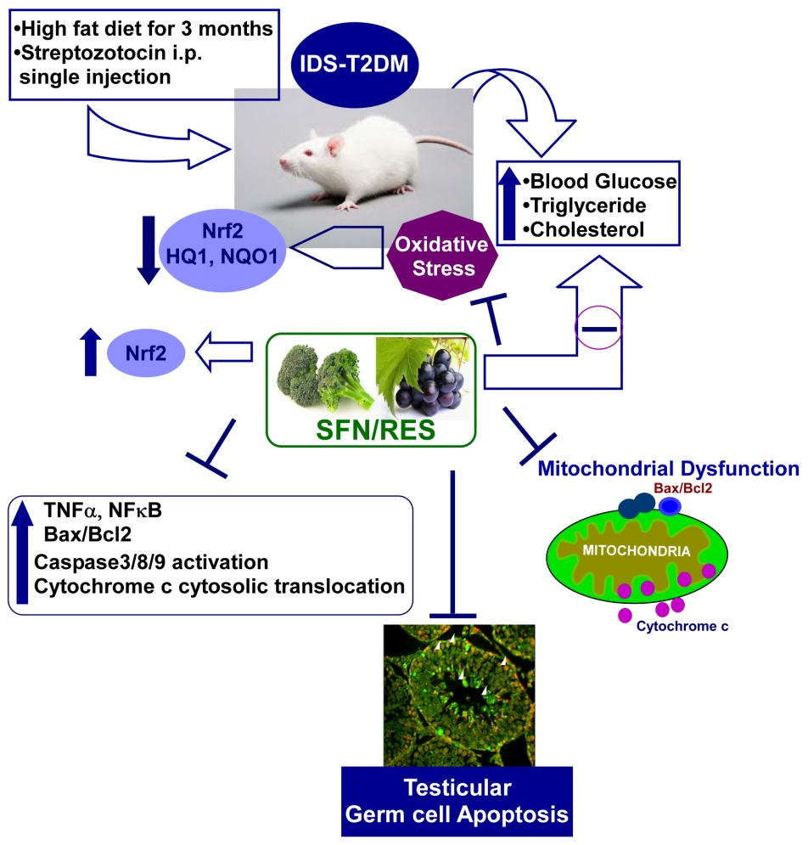Diabetes-induced testicular cell death is due predominantly to oxidative stress. Nuclear factor (erythroid- derived 2)-like 2 (Nrf2) is an important transcription factor in controlling the anti-oxidative system and is inducible by sulforaphane (SFN) and resveratrol (RES). To test whether SFN/RES prevents diabetes-induced testicular germ cell death/apoptosis, an insulin-defective stage of type 2 diabetes (IDS-T2DM) was induced in mice. This was accomplished by feeding them a high-fat diet (HFD) for 3 months to induce insulin resistance and then giving one intraperitoneal injection of streptozotocin to induce hyperglycemia while age-matched control mice were fed a normal diet (ND). IDS-T2DM and ND-fed control mice were then further subdivided into those with or without 3-months SFN/RES treatment. IDS-T2DM induced significant increases in testicular germ cell death/apoptosis presumably through receptor and mitochondrial pathways, shown by increased ratio of Bax/Bcl2 expression and cleavage of caspase-3 and caspase-8 without significant change of endoplasmic reticulum stress (GRP78/CHOP). Diabetes also significantly increased testicular oxidative damage and inflammation (TNFα and NFκB). All of these diabetic effects were significantly prevented by SFN/RES treatment with up-regulated Nrf2 expression. These results suggest that IDS-T2DM induces testicular germ cell death/apoptosis presumably through caspase-8 activation and mitochondria-mediated cell death pathways and also by significantly down-regulating testicular Nrf2 expression and function. SFN/RES up-regulates testicular Nrf2 expression and its target antioxidant expression, which was associated with significant protection of the testis from IDS-T2DM-induced germ cell death.

***(D) A microtubular dynamics interfering trans-stilbene derivative compound G drives G2/M arrest, apoptosis and impedes cancer progression.***

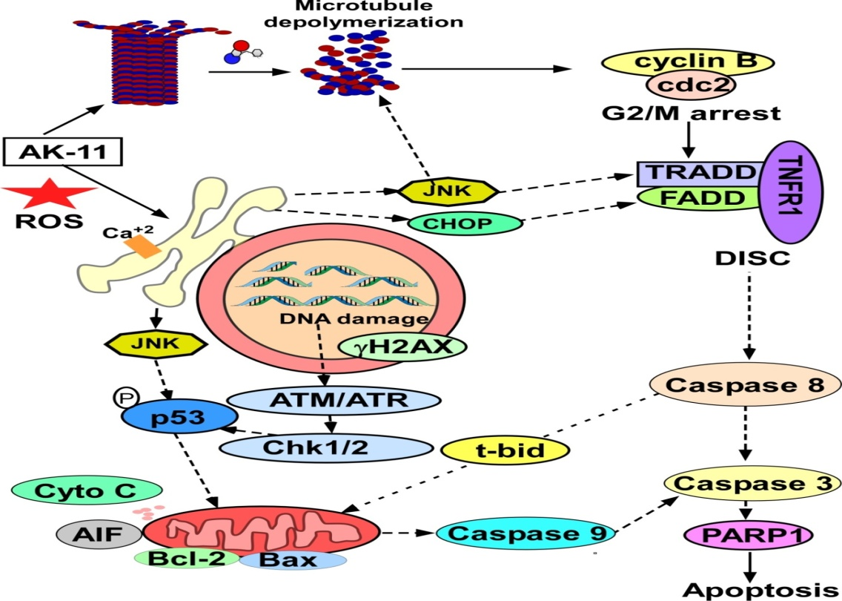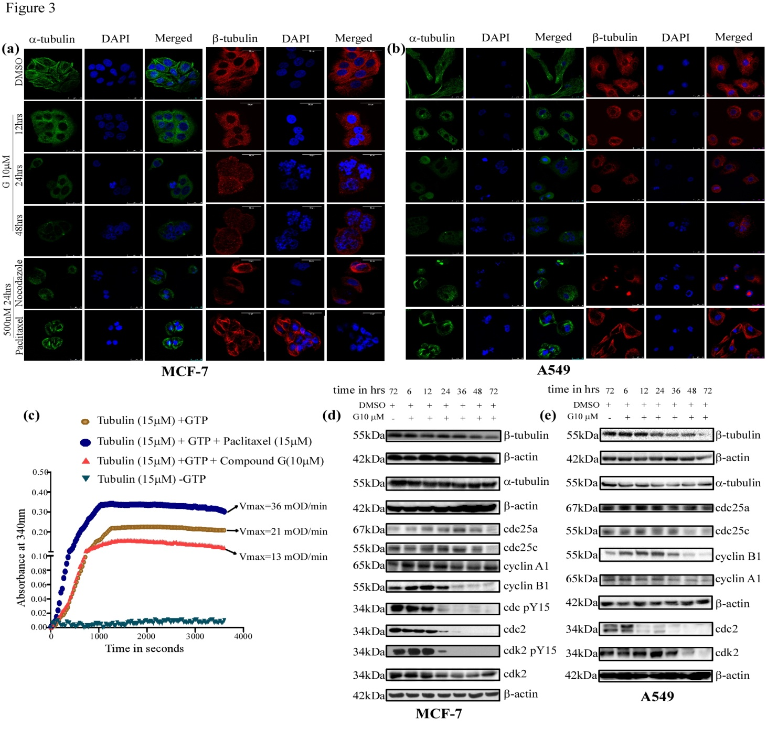Resveratrol, a *trans* –stilbene polyphenolic compound and its synthetic analogs have been widely used bioactive molecules due to their remarkable chemopreventive potential. Here, we have identified a novel resveratrol analog, compound G ((Z)-3-(3, 4-dimethoxyphenyl)-2-(3, 4, 5-trimethoxyphenyl) acrylonitrile whichinhibits proliferation of several cancer cell lines *in vitro* through microtubule depolymerization that induced G2M arrest and consequently leads to apoptotic cell death. Importantly, compound G shows limited cytotoxicity to normal cells as compared to cancer cells. Moreover, insight into the molecular and mechanistic detailed studies we reasoned that compound G induces increase in the expression of pro-apoptotic proteins and decrease in the expression anti-apoptotic proteins that decisively helps the activation of caspase 8, caspase 9, caspase 3, leading to PARP-1 and cell death via intrinsic and extrinsic pathways of apoptosis. More importantly, we also have established the crucial contribution of tumor suppressor protein p53 in compound G mediated apoptosis. Interestingly, the compound G also imparts its anti tumorigenic effect by inhibiting clonogenic property and anchorage independent growth potential of cancer cells. Finally, *in vivo* study with immune-competent syngeneic mice tumor model shows that administration of compound G is able to impede tumor progression without any side effects. So, our presently studied novel *trans*-stilbene derivative compound G has tremendous anti-tumorigenic potential and can be added to the current regimes of chemotherapy.

***(E) Oxidative stress plays major role in mediating apoptosis in filarial nematode Setaria cervi in the presence of trans-stilbene derivatives (In collaboration with Prof. S Sinhababu, Visva Bharati, Shantiniketan).***

Lymphatic filariasis, affecting around 120 million people in 80 countries worldwide, is an extremely painful disease and caused permanent and long term disability. Owing to its alarming prevalence there is immediate need for development of new therapeutics. A series of *trans-*stilbene derivatives were synthesized using aqueous reaction condition showing potential as antifilarial agents demonstrated in vitro. MTT reduction assay and dye exclusion test were performed to evaluate the micro and macrofilaricidal potential of these compounds. Amid twenty *trans*-stilbene derivatives together with Resveratrol (RSV), a multifunctional natural product was screened; nine compounds have showed promising micro and macrofilaricidal activities and four of them showed better effectiveness than RSV. In the treated parasites apoptosis was established by DNA laddering, in situ DNA fragmentation and FACS analysis. The generation of ROS in the treated parasites was indicated by the depletion in the level of GSH, GR and GST activity and elevation of SOD, catalase, GPx activity and superoxide anion and H2O2 level. Along with the ROS generation and oxidative stress, the decreased expression of anti-apoptotic ced-9 gene and increased expression of nematode specific pro-apoptotic genes, egl-1, ced-4 and ced-3 at the level of transcription and translation level; the up-regulation of caspase-3 activity and involvement of caspase-8, 9, 3, cytochrome-c and PARP were also observed and which denotes the probable existence of both extrinsic and intrinsic pathways apoptosis in parasitic nematodes. This observation is reported first time and thus it confirms the mode of action and effectiveness of the *trans*-stilbene compounds.



**(F) *Induction of Mitochondrial Apoptotic Pathway in Triple Negative Breast Carcinoma Cells by Methylglyoxal via Generation of Reactive Oxygen Species(In collaboration with Prof Manju Ray, CSIR-Emeritus Scientist & Bhatnagar Awardees, Bose Institute, Kolkata)***

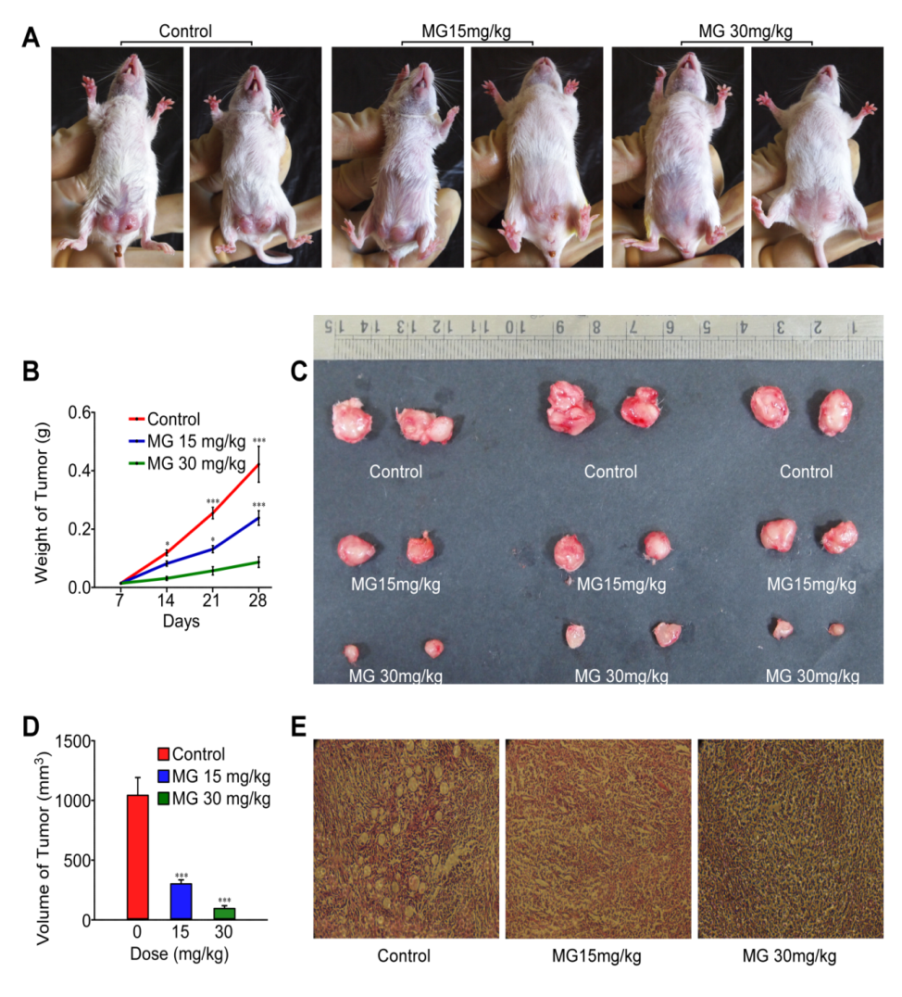Triple negative breast cancer (TNBC) tends to form aggressive tumors associated with high mortality and morbidity which urge the need for development of new therapeutic strategies. Recently the normal metabolite Methylglyoxal (MG) has been documented for its anti-proliferative activity against human breast cancer. However, the mode of action of MG against triple negative breast cancer remains open to question. In our study, we investigated the anticancer activity of MG in MDA MB 231 and 4T1 TNBC cell lines and elucidated the underlying mechanisms. MG dose-dependently caused cell death, induced apoptosis and generated ROS in both the TNBC cell lines. Furthermore, such effects were attenuated in presence of ROS scavenger N-Acetyl cysteine. MG triggered mitochondrial cytochrome c release in the cytosol and up-regulated Bax while down-regulated anti-apoptotic protein Bcl-2. Additionally, MG treatment down-regulated phospho-akt and inhibited the nuclear translocation of the p65 subunit of NF-κB. MG exhibited a tumor suppressive effect in BALB/c mouse 4T1 breast tumor model as well. The cytotoxic effect was studied using MTT assay. Apoptosis, ROS generation and mitochondrial dysfunction was evaluated by flow cytometry as well as fluorescence microscopy. Western blot assay was performed to analyse proteins responsible for apoptosis. This study demonstrated MG as a potent anticancer agent against TNBC both *in vitro* and *in vivo*. The findings will furnish fresh insights into the treatment of this subgroup of breast cancer.

***(G) Development of nanoparticle mediated treatment strategy to target NOTCH1 in triple negative breast cancer ( TNBC) Xenograft model (In collaboration with Prof. Parimal Karmakar, Jadavpur University).***

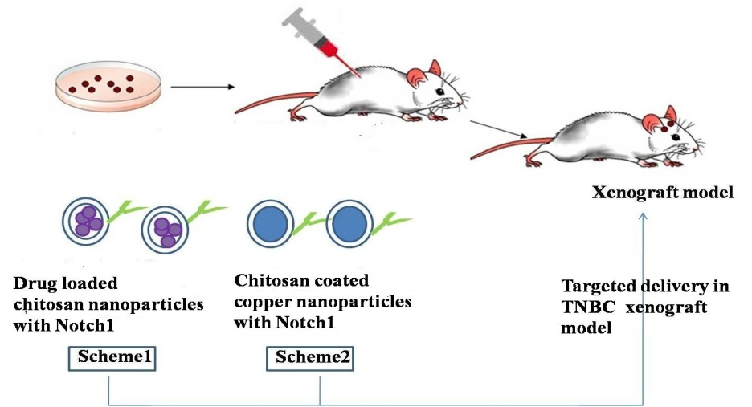The tumors with estrogen negative, progesterone negative and HER2-negative are known as triple-negative (TN) tumors and account for about 15% of breast tumors. These cells have poor prognostic outcome compared with other types of breast cancer. Treatment of TNBC limited due to the lack of a therapeutic target and as a result, these cells are chemo-resistance. As a matter of fact, Notch signaling pathway also have great role for chemo-resistance. These signaling pathway is a conserved pathway that has been involved in the determination of cell fate and self-renewal of a variety of cancer cells. This possible link between Notch signaling and breast cancer was established and Notch-1 exert an influence in tumor metastasis and proliferation in vivo. It was also shown that the expression of Notch 1 was enriched in triple negative breast cancer cells, where as normal breast cells exhibited very low or no dateable noth1 expression. However, the increased expression of Notch-1 in triple negative breast cancer has been associated with malignant tumor behavior and poor prognosis. To overcome this problem, nanoparticles may be used to deliver the drug in different cancer cells both in vitro and in vivo system. our focus is to delivery of drug loaded chitosan nanoparticles and copper coated chitosan nanoparticles tagged with Notch1 antibody for TNBC therapy. Due to its unique polymeric cationic character, chitosan has been extensively examined for the delivery system. We tried to load several anti-cancer drug such as doxorubicin and methoxtrate with chitosan nanoparticles or metal based nanoparticles such as Cu or Zn coated with chitosan. As mentioned before, there is very good strong correlation between the expression of Noth1 and TNBC. So, our target is to conjugate the Noth1 antibody with these nanoparticles. Initially, we examined the effect of these nanoparticles (both Noth1 conjugated or without Notch1 conjugated) on different sub type of breast cancer cells such as MDA-MB-231 (ER–, PR–, HER2–), MCF-7 (ER+, PR+/–, HER2–), BT-474 (ER+, PR+, HER2+), MDA-MB-453(ER–, PR–, HER2+). Next, we will try to focus on the exact molecular mechanism of cell death. The mouse models of human cancer are valuable tools for cancer research. So, we will also develop the TNBC xenograft model in immunodeficient mouse. The targeted drug or nanodrug delivery through chitosan nanoparticles tagged with Notch1 antibody will be therapeutic approach for treatment of chemo resistant triple negative breast cancer cells. Successful development of these kind of strategy for targeted delivery in TNBC xenograft model has tremendous application for overcome chemo-resistance of TNBC.

***(H) Exploration of molecular cross-talk involved in the roadmap to hyperhomocysteinemia- induced pregnancy loss in Polycystic Ovarian Syndrome (PCOS) (In collaboration with Prof. Baidyanath Chakravorty, Institute of Reproductive Medicine, Kolkata).***

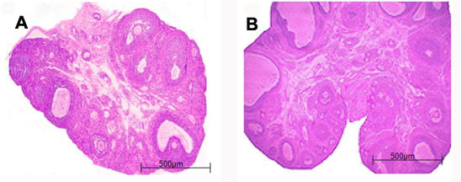Toelucidate the cause and effect links between different metabolic associates of polycystic ovary syndrome (PCOS) induced by experimental hyperhomocysteinemia (HHcy), We evaluated for magnitude of HHcy and the basic tenets of PCOS including i) development of polycystic ovaries and loss of cyclicity, ii) altered gonadotropin status, iii) hyperandrogenemia, iv) glucose intolerance and insulin resistance (IR). The effect of Hcy on insulin-mediated cellular uptake of 2-deoxy-D-[1-3H] glucose was evaluated in L6 rat skeletal muscle cell line *in vitro*. Expression of certain regulatory factors concerned with ovarian steroidogenesis (Wnt4, steroidogenic acute regulatory protein (StAR), and aromatase), follicular recruitment (ovarian anti-Mullerian hormone (AMH)), homocysteine metabolism (liver methylenetetrahydrofolate reductase (MTHFR)) and IR (liver calpain 10 (CALP10)) were analyzed by qRT-PCR. The treated rats developed moderate degree of HHcy and replicated the morphologic as well as many metabolic spectra of PCOS. The loss of estrus cyclicity was characterized by persistent estrous. They had ovarian follicular abnormalities that resembled human PCOS in several respects; i.e. the ovaries had many cystic follicles characterized by increased theca interna, diminished granulosa cell compartment, and fewer or no functional corpora lutea. Hcy attenuated insulin-mediated cellular uptake of glucose *in vitro* in a dose-dependent manner. The treated rats had higher expression of liver CALP10 and exhibited significant glucose intolerance, IR and dyslipidemia. Expressions of Wnt4, aromatase and MTHFR were down-regulated, while there was overt expression of StAR and increased serum levels of testosterone. This preliminary study provides data to construct a hypothesis that HHcy exerts multifaceted actions. In one end it induces IR and glucose intolerance by way of inhibiting glucose transport as well as glycogen synthesis, while on the other hand HHcy attenuates Wnt4 signaling cascade that inducts stimulation of StAR and inhibition of aromatase to overpower ovarian androgen synthesis. HHcy and hyperandrogenemia, individually or collectively, down-regulates ovarian AMH and increase the number of recruited follicles in the growth trajectory. Down-regulation of MTHFR prohibits the Hcy transmethylation pathway and helps maintain HHcy. Experimental HHcy in rats develops an array of biochemical and ovarian phenotypes that characterize the major morphologic as well as metabolic tenets of PCOS. HHcy therefore appears not to be a mere associate of PCOS, rather a causal factor in the pathogenesis of the syndrome. There are, however, several inherent limitations in the drink-based induction of HHcy. Development of genetic model by HHcy by targeted gene deletion or transgenic expression of selective human genes may serve as a useful model of PCOS.

***7. Experience in Translational Animal Research works:***

***More than 20 years of experience in animal handling, breeding, experimentation and treatment as well as more than 50 International publications related to small and large animals. Worked with StAR and COX-2 knockout mouse as well as COX-2 over expressed Transgenic mouse in Garrison Institute on Aging, Texas Tech University of Health Sciences Centre, Texas, USA. Attended, participated and organized several rat and mouse Bio-methodology workshops.***

***I am established myself as a highly motivated and vibrant Animal Research Scientist as well as Molecular Reproductive Biologist and Endocrinologist at Div. of Mol. Medicine, Bose Institute, Kolkata. I have taken a pioneer role to establish the State of the Art and world class Centre for Translational Animal Research (CTAR), a Central Animal House and Research Facility in North Eastern Part of India and did innovative research in the areas of Modern Laboratory Animal Sciences. I have a significant and unique experience in the maintenance and management of knockout/transgenic & Xenograft mouse facility. I am well versed with the L***[***aws***](http://en.wikipedia.org/wiki/Laws) ***or*** [***guidelines***](http://en.wikipedia.org/wiki/Guideline) ***that permit and control the use of non-human animals for*** [***scientific experimentation***](http://en.wikipedia.org/wiki/Scientific_experimentation)***. I worked several years in USA in close association with Jackson Laboratories. I was participated in several seminars, workshops related with the experiments on animals and drug testing. I am the member in several National & International Committees related with animal welfare. I am well versed with the Guide for the Care and Use of Laboratory Animals in Bio-medical Research in USA, UK, and Canada etc. I have more than 20 years of experience on Standard Operating Procedures (SOP) for Institutional Animal Ethics Committee (IAEC) of the CPCSEA.***

***8. Development of the Animal Research Facility at Bose Institute.***

I am serving as a Member Secretary/Scientist- In-Charge, Central Animal House & Research Facility as well as in "**Institutional Animal Ethics Committee (IAEC)"** & takes active participation to establish and maintenance of “**Central Animal House & Research Facility"** at Bose Institute.This is a *state of the art* world class environmentally controlled "Central Animal House and Research Facility” for Developmental and Toxicology Research" with all facilities for breeding, maintenance, experimentation on small laboratory animals and it has been exclusively developed in a plinth area of 15,000 sq. ft. This Animal facility will be utilized for experimental research in accordance with the principles of good laboratory practices and CPCSEA, Ministry of Environment, Forest & Climate Change, Government of India guidelines. Further, it facilitates research and development in partnership with academic Institutions, Industries and funding agencies for drug discovery-cum-validation and devices of translational medical research with the basic objective of advancement of biological knowledge which is useful for saving the lives and /or alleviating the suffering of human being, animals and plants. However such experiments are performed with due care so as to minimize the pain inflicted on animals. The Centre is also involved in skilled manpower development through education and training in laboratory animal care and experimental techniques. The main objective of the Centre is to supply defined strains of laboratory animals like mice, rats, guinea pigs, hamsters and rabbits for Bio-medical Research to the scientific community of the Eastern and North eastern part of India.

**Future Planning:** In view of global competitiveness, there is an urgent as well as strong need to synthesise molecules as new chemical entities which may be considered for IPR protections provided data on these entities can be generated in specific genetically engineered strains, species and animal models for disease like diabetes, hyperlipidaemia, hypertension, immunodeficiency and cancer etc. It becomes crucial for the laboratories to develop facilities where these activities are thoroughly evaluated and labs are able to provide data, which is acceptable to regulatory authorities. Unless we able to get these opportunities within the Country, it would be extremely difficult for the Scientists as well as institutions to obtain global marketing rights for drugs**. Hence, it is an utmost need to set up here a state-of-the-art well-equipped transgenic/ knockout/ Xenograft mouse laboratory (Centre for Translational Animal Research) for the Scientists of Eastern & North Eastern part of India. (A MOU already signed with TATA Medical Centre, Kolkata to develop this kind of facility with the help of DBT funding)**

***9. Collaborators:***

***1. Prof. Sanghamitra Raha, Visva Bharati, Santiniketan, India.***

***2. Prof. Parimal C. Sen, Bose Institute, Kolkata***

***3. Prof. Sujoy Guha, Indian Institute of Technology, Kharagpur***

***4. Prof. Narayan Jana, Institute of Post-Graduate Medical Education & Research, Kolkata***

***5. Prof. Parimal Karmakar, Dept. of Life Sciences & Biotech, Jadavpur University, Kolkata.***

***6. Prof. Baidyanath Chakraborty, Institute of Reproductive Medicine, Kolkata.***

***7. Dr. Debasish Bandopadhyay, University of Calcutta, Kolkata.***

***8. Prof. Manikuntala Kundu and Prof. Manju Ray, Bose Institute, Kolkata***

***9. Prof. Anup Kr. Misra & Dr. Kaushik Biswas, Bose Institute, Kolkata.***

***10. Awards/Honor Received:***

1. ***The Biography included in Americas “Who’s Who in Medicine & Healthcare”, 2008-2009.***
2. ***DST-Fast-Track Young Scientist Scheme Award, 2010.***
3. ***Young Scientist Travel Award, 2010 from ACC&D (Portland, Oregon, U.S.A.)***
4. ***Young Investigator Award, 2011 from Parsemus Foundation (San Francisco, California, USA).***
5. ***Nominated as “International Scientist of the Year, 2011” by International Biographical Centre, Cambridge, U.K.***
6. ***Scientific Award of Excellence for 2011" by American Biographical Institute, San Francisco, California, U.S.A.***
7. ***Young Scientist Travel Award, 2012, from International Congress on Animal Reproduction (ICAR)”, Vancouver, British Columbia, Canada.***
8. ***Young Scientist (Clinical) Award-2012” from Parsemus Foundation, Berkley, California, U.S.A.***
9. ***Selected and Trained as an Expert Consultant of CPCSEA, Ministry of Environment & Forests, Govt. of India.***
10. ***Young Scientist Travel Award, 2013 from ACC&D (Portland, Oregon, U.S.A.)***

***11. Young Scientist Award, 2014 from Parsemus Foundation, Berkley, California, U.S.A.***

***12. Outstanding Scientist Award, 2015 from Venus International Foundation, India.***

***13. Bharat Bikas Award, 2017 for outstanding contribution in Molecular Medicines.***

***14. Rastriya Gaurav Award, 2018***

***11. Editors/Editorial Board:***

1. ***Translational Medicine***
2. ***International Journal of Plant Physiology & Biochemistry***
3. ***Journal of Diabetes & Endocrinology***
4. ***International Journal of Clinical Therapeutics and Diagnosis (IJCTD)***
5. ***American Journal of Medical & Biological Research (AJMBR)***
6. ***Journal of Cell and Molecular Biology Research (JCMBR)***
7. ***Journal Of Animal Reproduction Studies***
8. ***Journal of Translational Medicine and Epidemiology.***
9. ***Journal of Preventive Medicine***
10. ***Reproductive Biology Insights***
11. ***Journal of Preventive Medicine***
12. ***Journal of Cancer Research and Molecular Medicine***
13. ***Journal of Medicine and Medical Sciences***
14. ***Annals of Translational Medicine & Epidemiology***
15. ***Frontiers in Endocrinology***
16. ***Journal of Collaborative Heath Care & Translational Medicine***
17. ***International Journal of Obstetrics and Gynecology***
18. ***Advances in Applied Physiology***
19. ***Austin Endocrinology & Diabetes case Reports.***
20. ***Archives of Endocrinology***
21. ***International Journal of Biochemistry & Physiology***
22. ***Journal of Molecular Genetics & Medicine***
23. ***Current Clinical Pharmacology***
24. ***American Journal Pharmacy & Pharmacology***
25. ***Journal of Molecular Sciences etc.***

***12. Reviewer:***

**1. Journal of Endocrinology/Endocrinology 2. Molecular Cellular Endocrinology 3.Toxicological Sciences 4. Andrology 5. Asian Journal of Andrology 6. Food & Chemical Toxicology 7. Ecotoxicology & Environmental Safety 8. Fertility & Sterility 9. Contraception 10. Reproductive Toxicology 11. Molecular Cellular Biochemistry 12. Molecular Reproduction & Development 13. Journal of Trace Elements in Medicine & Biology 14. Molecular Human Reproduction 15. Life Sciences and Reproduction etc.**

***13. Member of Scientific Bodies:***

|  |
| --- |
| **1. The Science Advisory Board, U.S.A.** |

**2. Society for the Study of Reproduction and Fertility**

**3. Society for Reproductive Biology and Comparative Endocrinology.**

**4. The Society of Physiology.**

**5. Indian Society for Translational Research**

**6. DNA Society of India**

***14. Ph.D. guidance*:**

**Two are already awarded and Four students (SRFs) have already been registered under the Ph.D. Programme in the University of Calcutta where I am acting as a Supervisor/Co-supervisor. Three JRFs will be registered soon in different Departments of Calcutta University. One DBT-RA and one CSIR-Project RA are also working under my supervision.**

***15. Teaching activities:***

**Taught and taken special paper classes in Biochemistry (Cell signalling, hormone action, cancer signalling and Immunology) and Environmental Science (Toxicology and pharmacology, Reproductive and endocrine disorders etc.) of M.Sc. (Physiology) students of University of Calcutta as well as Integrated M.Sc.-Ph.D. classes at Bose Institute.**

***16. CPCSEA, Ministry of Environment, Forest & Climate Change, Govt. Of India Nominee:***

***Serving as a "CPCSEA Nominee" in different Institutes like Visva Bharati, Chittaranjan National Cancer Institute, Indian Institute of Chemical Biology (IICB), Indian association for the Cultivation of Science (IACS), Jadavpur University, Vidyasagar University, Institute of Post-graduate Medical Education & Research (IPGMER) , Institute of Reproductive Medicine, IQ City Medical College, Cris Biotech etc.***

***17. List of Extramural Funded Projects:***

***1. SERC Fast Track Proposals for Young Scientist Research Scheme Entitled " Molecular Signalling Involved in patho-physiological Action of Common Air Pollutant Benzo(a)pyrene in Testicular DNA Damage and Apoptosis in Connection to Male Infertility: Possible Protection by Natural Aryl Hydrocarbon Receptor antagonists" from DST, Govt. of India. (PI: Dr. Kuladip Jana). (Completed on 31st March, 2015)***

***2. “Targeted delivery of nano-conjugated Methylglyoxal to cancer cells and understanding the bioenergetics difference between normal and malignant cells at molecular level” from DST, Govt. of India. (PI: Prof. Manju Ray; Co-PI: Dr. Kuladip Jana), (Project started from 01 January, 2014 with an appointment of a JRF and a R.A.)***

***3. “Assessment of the anti-cancer effect of Methylglyoxal in combination with conventional anti-cancer drugs at metronomic doses with special reference to cancer stem cells” from CSIR, Govt. of India (PI: Prof. Manju Ray; Co-PI: Dr. Kuladip Jana), (Project funded on 10/05/2016).***

***18. Attended National & International Conferences****:*

*Attended several National and International conferences and delivered lectures and chaired sessions.*

19. List of Important research publications: (Corresponding Author: 20; Citations: 1420)

1. [Datta C](https://www.ncbi.nlm.nih.gov/pubmed/?term=Datta%20C%5BAuthor%5D&cauthor=true&cauthor_uid=29749704), [Subuddhi A](https://www.ncbi.nlm.nih.gov/pubmed/?term=Subuddhi%20A%5BAuthor%5D&cauthor=true&cauthor_uid=29749704), [Kumar M](https://www.ncbi.nlm.nih.gov/pubmed/?term=Kumar%20M%5BAuthor%5D&cauthor=true&cauthor_uid=29749704), [Lepcha TT](https://www.ncbi.nlm.nih.gov/pubmed/?term=Lepcha%20TT%5BAuthor%5D&cauthor=true&cauthor_uid=29749704), [Chakraborty S](https://www.ncbi.nlm.nih.gov/pubmed/?term=Chakraborty%20S%5BAuthor%5D&cauthor=true&cauthor_uid=29749704), [Jana K](https://www.ncbi.nlm.nih.gov/pubmed/?term=Jana%20K%5BAuthor%5D&cauthor=true&cauthor_uid=29749704), [Ghosh Z](https://www.ncbi.nlm.nih.gov/pubmed/?term=Ghosh%20Z%5BAuthor%5D&cauthor=true&cauthor_uid=29749704), [Mukhopadhyay AK](https://www.ncbi.nlm.nih.gov/pubmed/?term=Mukhopadhyay%20AK%5BAuthor%5D&cauthor=true&cauthor_uid=29749704), [Basu J](https://www.ncbi.nlm.nih.gov/pubmed/?term=Basu%20J%5BAuthor%5D&cauthor=true&cauthor_uid=29749704), [Kundu M](https://www.ncbi.nlm.nih.gov/pubmed/?term=Kundu%20M%5BAuthor%5D&cauthor=true&cauthor_uid=29749704). Genome-wide mRNA-miRNA profiling uncovers a role of the microRNA miR-29b-1-5p/PHLPP1 signalling pathway in Helicobacter pylori-driven matrix metalloproteinase production in gastric epithelial cells. [**Cell Microbiology**](https://www.ncbi.nlm.nih.gov/pubmed/29749704), 2018; e12859.
2. Pal K, Laha D, Parida PK, Jana K, Karmakar P. An In Vivo Study for Targeted Delivery of Curcumin in Human Triple Negative Breast Carcinoma Cells Using Biocompatible PLGA Microspheres Conjugated with Folic Acid. **Journal of Nanoscience and Nanotechnology, 2018;** 18:16292

1. Das M, Banerjee B, Sen A, Basu S, Jana K, Dutta G. Hepatoprotective Effects of Green Capsicum annum against Ethanol Induced Oxidative Stress, Inflammation and Apoptosis in Rats. **Journal of Ethnopharmacology** 2018 (In Press).
2. Parida, PK, Raha, S. Misra AK, Biswas K, Jana K. Inhibition of cancer progression by a novel trans-stilbene derivative of Resveratrol by interfering with microtubule dynamics, driving G2/M arrest and p53-dependent apoptosis. **Cell Death & Disease (Nature)**. 2018; 9: 448.
3. Ghosh R, Banerjee B, Das T, Jana K, Choudhury SM. [Antigonadal and endocrine-disrupting activities of lambda cyhalothrin in female rats and its attenuation by taurine.](https://www.ncbi.nlm.nih.gov/pubmed/29506456) **Toxicol Ind Health.** 2018; 34:146-157.
4. Sarkar MB, Sircar G, Ghosh N, Das AK, Jana K, Dasgupta A, Bhattacharya SG. [Cari p 1, a Novel Polygalacturonase Allergen From Papaya Acting as Respiratory and Food Sensitizer.](https://www.ncbi.nlm.nih.gov/pubmed/29967633) **Frontier in Plant Science**. 2018, 18; 9: 823.
5. Sarkar P, Jana K, Sikdar SR. [Overexpression of biologically safe Rorippa indica defensin enhances aphid tolerance in Brassica juncea.](https://www.ncbi.nlm.nih.gov/pubmed/28770337) **Planta** 2017, 246:1029-1044.
6. Gucchait A, Joardar N, Parida PK, Yesuvadian R, SinhaBabu SP, Jana K, Misra AK. Development of novel anti-filarial agents using carbamo(dithioperoxo)thioate derivatives  
   **European Journal of Medicinal Chemistry** 2017;143:598-610.
7. Roy A, Ahir M, Bhattacharya S, Parida PK, Adhikary A, Jana K, Ray M. [Induction of Mitochondrial Apoptotic Pathway in Triple Negative Breast Carcinoma Cells by Methylglyoxal via Generation of Reactive Oxygen Species.](https://www.ncbi.nlm.nih.gov/pubmed/28418078) **Molecular Carcinogenesis** 2017, 56:2086-2103
8. A Gucchait, K Jana, AK Misra. [Convenient preparation of thioglycomimetics: S-glycosyl sulfenamides, sulfinamides and sulphonamides](https://scholar.google.co.in/citations?view_op=view_citation&hl=en&user=sWruwcMAAAAJ&cstart=40&citation_for_view=sWruwcMAAAAJ:blknAaTinKkC) **RSC Advances 2017,** 7: 32478-32487.
9. [Sahu](http://www.pubfacts.com/author/Sanjaya+Kumar+Sahu) SK,  [Kumar](http://www.pubfacts.com/author/Ranjeet+Kumar) M, Banerjee S, Kumar R, Gupta P, Jana K,  [Gupta](http://www.pubfacts.com/author/Pushpa+Gupta) UD, Ghosh Z, Kundu M, Basu J. "miR-26a-KLF4 and CREB-C/EBP beta regulate innate immune signalling, the polarization of macrophages and the trafficking of Mycobacterium tuberculosis to lysosomes during infection. **PLoS Pathogen** 2017, 13:e1006410.
10. Dutta A, Dhara D, Parida PK, Si A, Yesuvadian, R, Jana K & Misra AK. C-Glycosylated cinnamoylfuran derivatives as novel anticancer agents. **RSC Advances** 2017, 7: 28853-28864
11. Banerjee B, Nandi P, Chakraborty S, Raha S, Sen PC, Jana K. Resveratrol ameliorates benzo(a)pyrene induced testicular dysfunction and apoptosis through p38 MAPK/ATF2/iNOS signalling. **The** **Journal of Nutritional Biochemistry** 2016, 34: 17-29.
12. [Banerjee A](http://www.ncbi.nlm.nih.gov/pubmed/?term=Banerjee%20A%5BAuthor%5D&cauthor=true&cauthor_uid=27494525), [Sanyal S](http://www.ncbi.nlm.nih.gov/pubmed/?term=Sanyal%20S%5BAuthor%5D&cauthor=true&cauthor_uid=27494525), [Dutta S](http://www.ncbi.nlm.nih.gov/pubmed/?term=Dutta%20S%5BAuthor%5D&cauthor=true&cauthor_uid=27494525), [Chakraborty P](http://www.ncbi.nlm.nih.gov/pubmed/?term=Chakraborty%20P%5BAuthor%5D&cauthor=true&cauthor_uid=27494525), [Das PP](http://www.ncbi.nlm.nih.gov/pubmed/?term=Das%20PP%5BAuthor%5D&cauthor=true&cauthor_uid=27494525), [Jana K](http://www.ncbi.nlm.nih.gov/pubmed/?term=Jana%20K%5BAuthor%5D&cauthor=true&cauthor_uid=27494525), [Vasudevan M](http://www.ncbi.nlm.nih.gov/pubmed/?term=Vasudevan%20M%5BAuthor%5D&cauthor=true&cauthor_uid=27494525), [Das C](http://www.ncbi.nlm.nih.gov/pubmed/?term=Das%20C%5BAuthor%5D&cauthor=true&cauthor_uid=27494525), [Dasgupta D](http://www.ncbi.nlm.nih.gov/pubmed/?term=Dasgupta%20D%5BAuthor%5D&cauthor=true&cauthor_uid=27494525). The plant alkaloid chelerythrine binds to chromatin, alters H3K9Ac and modulates global gene expression. **Journal of Biomolecular Structure and Dynamics.** 2016; 5: 1-9.
13. Sirkar G., Jana, K., Dasgupta A., Saha S., Gupta Bhattachrya, S. Epitope mapping of Rhio 1 and Generation of a Hypoallergenic Variant: a Candidate Molecule for Fungal Allergy Vaccines. **The Journal of Biological Chemistry** 2016; 291:18016-29.
14. Banerjee B, Nandi P, Chakraborty S, Raha S, Sen PC, Jana K. Curcumin and resveratrol synergistically prevent benzo(a)pyrene induced male germ cell apoptosis by modulating MAPKs and p53. **Frontiers in Pharmacology** 2016; 7:245.
15. Banerjee, S., Kumar, M., Alokam, R., Sharma, A.K, Chatterjee, A., Jana K. Singh R, Yogeeswari P, Sriram D, Basu J, Kundu M. Targeting multiple response regulators of Mycobacterium tuberculosis augments the host immune response to infection. **Scientific Reports** 2016; 6: 25851.
16. Ghosh, R, Pradhan A, Maity P, Jana K, Maiti Choudhury S. Lipid peroxidative damage, alteration in antioxidant status and morphological changes in rat erythrocytes on Lambda-cyhalothrin exposure and its attenuation by taurine. **Toxicology and Environmental Health Sciences.** 2016, 8: 315-326.
17. Gucchait A, Jana M, Jana K, Misra AK. [Preparation of glycosyl thiourea derivatives from glycosyl azides using sulfamic acid and sodium iodide in one-pot.](https://www.ncbi.nlm.nih.gov/pubmed/27639336) **Carbohydrate Research.** 2016, 434: 107-112.
18. Dinda, M., Chakraborty, M., Ganguly, D., Dasgupta, U., Dutta, A., Jana, K., Karmakar, P. The water fraction of Calendula officinalis hydroethanol extract stimulates in vitro and in vivo proliferation of dermal fibroblasts in wound healing. **Phytotherapy Research** 2016 doi: 10.1002/ptr.5678.
19. Roy P, Dhara D, Parida PK, Kar RK, Bhunia A, Jana K., Misra AK. [C-cinnamoyl glycosides as a new class of anti-filarial agents.](http://www.ncbi.nlm.nih.gov/pubmed/27015610) **European Journal of Medicinal Chemistry.** 2016; 114:308-17.
20. Mukherjee N, Parida PK, Santra A, Ghosh T, Dutta A, Jana K, Misra AK, Sinha Babu SP. [Oxidative stress plays major role in mediating apoptosis in filarial nematode Setaria cervi in the presence of trans-stilbene derivatives.](http://www.ncbi.nlm.nih.gov/pubmed/26849945) **Free Radical Biology & Medicine.** 2016; 93:130-44. ***Senior Author***
21. Kumar R, Sahu SK, Kumar M, Jana K, Gupta P, Gupta UD, Kundu M, Basu J. [MicroRNA 17-5p regulates autophagy in Mycobacterium tuberculosis-infected macrophages by targeting Mcl-1 and STAT3.](http://www.ncbi.nlm.nih.gov/pubmed/26513648) **Cellular Microbiology** 2016; 18:679-91.
22. Halder P, Kumar R, Jana K, Chakraborty S, Ghosh Z, Kundu M, Basu J. [Gene expression profiling of Mycobacterium tuberculosis Lipoarabinomannan-treated macrophages: A role of the Bcl-2 family member A1 in inhibition of apoptosis in mycobacteria-infected macrophages.](http://www.ncbi.nlm.nih.gov/pubmed/26337784) **IUBMB Life** 2015; 67:726-36.
23. [Kumar](http://www.pubfacts.com/author/Manish+Kumar) M,  [Sahu](http://www.pubfacts.com/author/Sanjaya+Kumar+Sahu) SK,  [Kumar](http://www.pubfacts.com/author/Ranjeet+Kumar) R,  [Subuddhi](http://www.pubfacts.com/author/Arijita+Subuddhi) A,  [Maji](http://www.pubfacts.com/author/Ranjan+Kumar+Maji) RK, Jana K,  [Gupta](http://www.pubfacts.com/author/Pushpa+Gupta) P, [Raffetseder](http://www.pubfacts.com/author/Johanna+Raffetseder) J, [Lerm](http://www.pubfacts.com/author/Maria+Lerm) M., Ghosh Z, van Loo G, Beyaert R, Gupta UD, Kundu M, Basu J.[Micro RNA let-7 Modulates the Immune Response to Mycobacterium tuberculosis Infection via Control of A20, an Inhibitor of the NF-κB Pathway.](http://www.pubfacts.com/detail/25683052/MicroRNA-let-7-Modulates-the-Immune-Response-to-Mycobacterium-tuberculosis-Infection-via-Control-of-) **Cell Host & Microbe** 2015, 17:345-56.
24. Ray M, Rai N, Jana K, Ghatak S, Basu A, Mustafi SB, Raha S. [Beta catenin is degraded by both caspase-3 and proteasomal activity during resveratrol-induced apoptosis in HeLa cells in a GSK3β-independent manner.](http://www.ncbi.nlm.nih.gov/pubmed/26040106) **Indian J Biochem Biophys.** 2015, 52:7-13.
25. Banerjee A, Sanyal S, Majumder P, Chakraborty P, Jana K, Das C, Dasgupta D. [Recognition of chromatin by the plant alkaloid, ellipticine as a dual binder.](http://www.ncbi.nlm.nih.gov/pubmed/25960297) **Biochemical and Biophysical Research Communications.** 2015, 462: 352-7.
26. Nandi P, Banerjee B, Ghosh S, Chakrabarty A, Jana K and Sen PC. Involvement of Nifetepimine in Motility and Capacitation of Caprine Spermatozoa **American Journal of Experimental Biology** 2014, 1: 61-84.
27. Banerjee A, Sanyal S, Kulkarni KK, Jana K, Roy S, Das C, Dasgupta D. [Anticancer drug mithramycin interacts with core histones: An additional mode of action of the DNA groove binder.](http://www.ncbi.nlm.nih.gov/pubmed/25473595) **FEBS Open Bio.** 2014, 4: 987-95.
28. Syed Benazir Firdaus, Ghosh A, Chattyopadhyayb A, Jana K & Bandyopadhyay D. Protective effect of antioxidant rich aqueous curry leaf (Murraya koenigii) extract against gastro-toxic effects of piroxicam in male Wistar rats. **Toxicology Reports** 2014, 1: 987-1003.
29. Jana K, Dutta A, Chakraborty P, Manna I, Firdaus SB, Bandyopadhyay D, Chattopadhyay R, Chakravarty B. α- lipoic acid and N-acetylcysteine protects intensive swimming exercise mediated germ cell depletion, pro-oxidant generation and alteration of steroidogenesis in rat testis. **Molecular Reproduction & Development** 2014, 81: 833-50.
30. Parida PK, Sau A, Ghosh T, Jana K, Biswas K, Raha S, & Misra AK. Synthesis and evaluation of triazole linked glycosylated 18 beta-glycyrrhetinic acid derivatives as anticancer agents. **Bioorganic & Medicinal Chemistry Letters** 2014, 24: 3865-8.
31. Syed Benazir Firdaus, Ghosh A, Chattyopadhyayb A, Jana K & Bandyopadhyay D. A combination of aqueous curry (*Murraya koenigii*) leaf extract and melatonin protects against piroxicam induced gastric ulcer in male albino rats: Involvement of antioxidant mechanism(s). **Journal of Pharmacy Research** 2014, 8,428-436.
32. [Roy](http://omicsonline.org/cancer-stem-cells-wnt-hedgehog-and-notch-signaling-the-role-of-dietary-phytochemicals-new-insights-for-cancer-therapy-2161-1025.1000e125.php?aid=21525), A, Roy, M & Jana K. Cancer Stem Cells, Wnt, Hedgehog and Notch Signaling, the Role of Dietary Phytochemicals: New Insights for Cancer Therapy. **Translational Medicine**. 2014, 3:e125. doi: 10.4172/2161-1025.1000e125.
33. Banerjee A., Majumder P., Singh J., Jana K, Das C., Dasgupta, D. DNA intercalators, ethidium bromide and propidium iodide, bind to core histones. **FEBS Open Bio**, 2014 2014, 15: 251-9.
34. Chakraborty, P., Goswami, S.K., Rajani, S., Sharma, S., Kabir, S.N., Chakravarty BN., & Jana, K. Recurrent pregnancy loss in polycystic ovary syndrome: role of hyper-homocysteinemia and insulin resistance. **PLoS One** 2013; 8: e64446.
35. Jana, K., Banerjee, B. & Parida P.K. Caspases: A Potential Therapeutic Targets in the Treatment of Alzheimer’s disease. **Translational Medicine 2013;** S2: 006. Chakraborty, P., Goswami, S.K., Rajani, S., Sharma, S., Kabir, S.N., Chakravarty B.N., & Jana, K. Altered trace mineral milieu might play an aetiological role in the pathogenesis of polycystic ovary syndrome. **Biology of Trace Element Research** 2013**;** 152: 9-15.
36. Basu, A., Mukherjee, D., Ghosh, A.K., Mitra E., Firdaus, S.B., Ghosh, D., Jana, K., Bandyopadhyay, A., Chattopadhyay A. And Bandyopadhyay D. [Melatonin augments the protective effects of aqueous leaf homogenate of tulsi (ocimum sanctum l.) against piroxicam-induced gastric ulceration in rats](http://www.ajpcr.com/Vol6Issue2/1647.pdf). **Asian Journal of Pharmaceutical and Clinical Research** 2013**;** 6: 123-132.
37. Ghosh, D., Firdaus, S.B, Mitra, E., Dey, M., Chattopadhyay, A., Pattari, S.K., Dutta S., Jana, K. & Bandyopadhyay D. Hepatoprotective activity of aqueous leaf extract of Murraya koenigii against lead-induced hepatotoxicity in male wistar rat. **International Journal of Pharmacy and Pharmaceutical Sciences** 2013**;** 5: 285-295.
38. Basu, A., Mitra, E., Dey, M., Chattopadhyay, A., Pattari, S.K., Dutta S.K., Jana, K. & Bandyopadhyay, D. Aqueous tulsi leaf (ocimum sanctum l.) extract protects against piroxicam-induced gastric ulceration in rats: involvement of antioxidant mechanisms **International Journal of Pharmacy and Pharmaceutical Sciences** 2013**;** 5: 438-447.
39. Ghosh, D., Firdaus, S.B, Mitra, E., Dey, M., Chattopadhyay, A., Pattari, S.K., Dutta S., Jana, K. & Bandyopadhyay D. Aqueous leaf extract of Murraya koenigii protects against lead-induced cardio toxicity in male wistar rats. **International Journal of Phytopharmacology** 2013**;** 4: 119-132.
40. Ghosh, D., Firdaus, S.B, Mitra, E., Dey, M., Chattopadhyay, A., Pattari, S.K., Dutta S., Jana, K. & Bandyopadhyay D. Ameliorative effect of curry leaf aqueous extract against lead acetate induced oxidative stress in rat kidneys. **International Journal of Pharmacy and Pharmaceutical Sciences** 2013**;** 5: 546-556.
41. Jana, K. & Samanta, P.K. Clinical evaluation of non-surgical Sterilization of male Cats with Single intra-testicular Injection of Calcium Chloride. **BMC Veterinary Research** 2011**;** 7: 39.
42. Nandi, P., Charteerjee, S., Jana, K. & Sen, P.C. Role of a 14 kD sperm protein p14 in maturation, acrosome reaction and capacitation of caprine spermatozoa. **PLoS One** 2012; 7 :e30552.
43. Kumar, R., [Halder, P](http://www.ncbi.nlm.nih.gov/pubmed?term=Halder%20P%5BAuthor%5D&cauthor=true&cauthor_uid=22712528)., [Sahu, S.K](http://www.ncbi.nlm.nih.gov/pubmed?term=Sahu%20SK%5BAuthor%5D&cauthor=true&cauthor_uid=22712528)., [Kumar, M](http://www.ncbi.nlm.nih.gov/pubmed?term=Kumar%20M%5BAuthor%5D&cauthor=true&cauthor_uid=22712528)., [Kumari, M](http://www.ncbi.nlm.nih.gov/pubmed?term=Kumari%20M%5BAuthor%5D&cauthor=true&cauthor_uid=22712528)., Jana, K., [Ghosh, Z](http://www.ncbi.nlm.nih.gov/pubmed?term=Ghosh%20Z%5BAuthor%5D&cauthor=true&cauthor_uid=22712528)., [Sharma, P](http://www.ncbi.nlm.nih.gov/pubmed?term=Sharma%20P%5BAuthor%5D&cauthor=true&cauthor_uid=22712528)., [Kundu, M](http://www.ncbi.nlm.nih.gov/pubmed?term=Kundu%20M%5BAuthor%5D&cauthor=true&cauthor_uid=22712528). & [Basu, J](http://www.ncbi.nlm.nih.gov/pubmed?term=Basu%20J%5BAuthor%5D&cauthor=true&cauthor_uid=22712528). Identification of a novel role of ESAT-6-dependent miR-155 induction during infection of macrophages with Mycobacterium tuberculosis. [**Cellular Microbiology**](http://www.ncbi.nlm.nih.gov/pubmed/22712528) 2012; 14:1620-31.
44. Jana, K., Jana, N., De, D.K. & Guha, S.K. Ethanol induces mouse spermatogenic cell apoptosis in vivo through over expression of Fas/Fas-L, p53 and caspase-3 along with cytochrome c translocation and glutathione depletion. **Molecular Reproduction & Development** 2010; 77, 820-833.
45. Jana, K., Samanta, P.K. & De, D.K. Nicotine diminishes testicular gametogenesis, steroidogenesis and steroidogenic acute regulatory protein expression in adult albino rats: possible influence on pituitary gonadotropins and alters testicular antioxidant status. **Toxicological Sciences** 2010; 116: 647-659.
46. Jana, K., Yin, P., Schiffer, X., Grammas, P., Stocco, D.M. & Wang, X.J. Effect of Chrysin on steroidogenesis and steroidogenic acute regulatory gene expression in mouse MA-10 tumor Leydig cells. **Journal of Endocrinology 2008;** 197: 315-323.
47. Jana, K., Manna, I. & Samanta, P.K. Protective effect of sodium selenite and zinc sulfate on intensive swimming exercise- induced testicular gamatogenic and steroidogenic disorders in mature male rats. **Applied Physiology Nutrition and Metabolism** 2008; 33: 903-914.
48. Jana, K. & Samanta, P.K. Strilization of male stray dog by single intratesticular injection of calcium chloride. **Contraception 2007;** 75: 390-400.
49. Samanta, P.K., Manna, I. & Jana, K. Effect of L - ascorbic acid supplementation on testicular oxidative stress and reproductive dysfunctions in rats exposed to intensive exercise stress. **Reproductive Medicine and Biology 2006;** 5: 145-153.
50. Jana, K., Samanta, S. & Samanta, P.K. The possible estrogenic mode of action of sodium arsenite on pituitary- testicular activities in adult albino rats. **Reproductive Biology and Endocrinology** 2006; 4: 9- 22 .
51. Jana, K. & Samanta P.K. Evaluation of single intra-testicular injection of calcium chloride for non-surguical sterilization in adult albino rats. **Contraception 2006;** 73: 289-300.
52. Jana, K., Ghosh, D. & Samanta, P.K. Evaluation of single Intra-testicular injection of calcium chloride for non-surgical sterilization of male Black Bengal goats. (Capra-hircus): A dose dependent study. **Animal Reproduction Science** 2005; 86: 89-108 .
53. Manna, I., Jana, K. & Samanta, P.K. Effect of different intensities of Swimming Exercise on testicular oxidative stress and reproductive dysfunctions in mature male albino Wister rats. **Indian Journal of Experimental Biology** 2004; 42: 816-822.
54. Manna, I., Jana, K. & Samanta, P.K. Intensive swimming exercise induced oxidative stress and reproductive dysfunctions in male wistar rats: Protective role of α- tocoferol succinate. **Canadian Journal of Applied Physiology** 2004; 29: 172- 185.
55. Manna, I., Jana, K. & P. K. Samanta. Effect of intensive exercise-induced testicular gametogenic and steroidogenic disorders in matured male wistar strain rats: A correlative approach to oxidative stress. **Acta Physiologica** 2003; 178: 33-40.
56. Jana, K., Samanta, P.K. & Ghosh, D. Dose dependent response to an intra-testicular injection of calcium chloride for induction of chemosterilization in adult albino rats. **Veterinary Research Communications** 2002; 26: 651-663.

***Book Chapter:***

1. Jana, K. & Sen, P.C. Environmental Toxicants Induced Male Reproductive Disorders: Identification and Mechanism of Action. **Toxicity & Drug Testing** Edited by William Acree, In Tech Publication, Croatia, 2012, pp. 473-518.
2. Goswami, A., Sen, P., Jana, K. & Raha, S. Involvement of Caspases in Neurodegenaration and Stroke. Proteases and Neural Disorders. **Role of Proteases in Cellular Dysfunctio**n, Edited by Sajal Chakraborty and Naranjan S Dhalla, Springer Publisher, New York, USA. 2013, 8: pp 47-66.

**Under minor Revision:**

1. Saha S, Basu M, Guin S, Ray A, Gupta P, Mitterstiller A-M, Weiss G, Jana K, Ukil A. *Leishmania donovani* exploits macrophage heme oxygenase-1 to neutralize oxidative burst and TLR signaling dependent host defense. **Journal of Immunology** 2018.

2. Roy A, Sarker S, Upadhyay, P, Pal A, Adhikary A, Jana K, Roy M. Methylglyoxal sensitizes breast cancer cells to doxorubicin and cisplatin at metronomic doses causing synergistic induction of programmed cell death and inhibition of stemness. **Biochemical Pharmacology** 2018.

1. Prof. Subeer S. Majumder

Director

5. Prof. Arun Bandopadhyay

Sr. Principal Scientist & Professor

Chairman/HOD

**In-Charge, IICB-TRUE, Saltlake**

Cell Biology & Physiology Division

Indian Institute of Chemical Biology

4, Raja S.C. Mullick Road,  
Kolkata, West Bengal, India,Pin:-700 032

**Phone:** +91 33 2473 0492

Cell: 09433516720

Email: [arunb@iicb.res.in](mailto:arunb@iicb.res.in)

National Institute of Animal Biotechnology (NIAB),

Opp. Mysamma Temple & HP Petrol Pump,  
Extended Q City Road,  
Near Gowlidoddy,  
Hyderabad,  
Telangana, India

**PIN:** 500 049

Phone: 09818170750

**Tel:**+91 40 2312 0103  
**Telefax:** +91 40 2304 2740

Email:  [subeer@niab.org.in](mailto:subeer@niab.org.in), [director@niab.org.in](mailto:director@niab.org.in) /[admin@niab.org.in](mailto:admin@niab.org.in)

2. Prof. Samir Bhattacharya  
(Former Director IICB, Kolkata)  
INSA Golden Jubilee Research Professor

& Emeritus Professor,

School of Life Science  
Visva-Bharati (A Central University)  
Santiniketan - 731 235  
& CSIR-North-East Institute of Science and Technology,   
Jorhat - 785 006  
Phone: 03463-261268/ 261176 (Off.)  
           03463-262838 (Res.)  
Fax: 03463-261176

6.  Prof. Parimal Karmakar

Professor  & Chairman/Head,

Department of Life science & Bio-technology

Jadavpur University

188, Raja S.C. Mallick Rd,

Kolkata 700032

Ph. No. 09433366323

Email: [**pkarmakar_28@yahoo.co.in**](mailto:pkarmakar_28@yahoo.co.in)

Phone: 09232567066/9435514989/9433145002

Email: [bhattacharyasa@gmail.com](mailto:bhattacharyasa@gmail.com)

3. Prof. Sagartirtha Sarkar

Professor (full)

Genetics & Molecular Cardiology Lab

Department of Zoology

University of Calcutta

35 Ballygunj Circular Road

Kolkata-700019

Email: [sagartirtha.sarkar@gmail.com/](mailto:sagartirtha.sarkar@gmail.com/)[sszoo@caluniv.ac.in](mailto:sszoo@caluniv.ac.in)

Phone: 09830559871

4. Prof. Biswajit Mukherjee

Professor & Chairman/Head

Department of Pharmaceutical Technology   
Jadavpur University

188, Raja S C Mallick Road, Kolkata- 700 032  
Phone: +91-33-24146677/ 24572588 ; Fax: +91-33-24146677

Phone: 08420824897 E-mail ID: [Biswajit.mukherjee@jadavpuruniversity.in/biswajit55@yahoo.com](mailto:Biswajit.mukherjee@jadavpuruniversity.in/biswajit55@yahoo.com)